James Duncan

Data Mining: revision

Contents

What is Data Mining used for? 3

Methodology (CRISP -DM) 4

Where do we store data? 5

INCLUSIVE AND EXCLUSIVE ATTRIBUTE DESCRIPTION 7

SET DESCRIPTORS 8

Finding all patterns in the data (Possible Combinations) MULTIPLICATIVE SUM 8

STANDARD DEVIATION = FINDING HOW FAR AWAY FROM THE MEAN YOU ARE 9

Correlations 9

Regression 11

Calculating linear regression 11

Multiple linear regression 11

Data Similarity 11

This is referred to as n-Dimensional for n number of features 11

Euclidean distance 12

Normalisation 14

Standardisation 15

Data cleaning 15

Removing or clearing null values 16

Calculating Hughes phenomena 17

Filter by variance 18

Filter by Correlation 19

Find a Subset that is best for your model (A lot of different outcomes and a lot of computational power) 19

Shrinking the space by grouping 19

Dummies 20

One Hot Encoding 20

Types of Visualisation 21

Histograms (Bar Charts) 21

Models 23

Mean squared error 24

Other methods (maybe don’t need to know ) 25

Confusion Matrixes 25

Model training 28

K-Fold Cross Validation 29

Overfitting 31

Decision Trees 31

CALCULATING GINI IMPURITY 33

CALCULATING CART ALGORITHM USING GINI ( FUCKING AIDS) 34

Whitebox and Blackbox Models 34

Association Rules 35

n-choose-k 37

Information improvement (may require Domain knowledge) 37

Knowledge based systems 40

Production Rules 40

Fallacies of ambiguity 41

Argumentation ad hominem 41

Fallacy of arguing from authority 41

Fallacies that appeal to sentiments 41

Argumentum ad ignorantiam 41

Begs the Question 41

Fallacy of Composition 41

fallacy of division 41

Fallacy of ignoratio elenchi 41

Fallacy of non sequitur 41

Statistical Fallacies 41

Expert systems 41

# What is Data Mining used for?

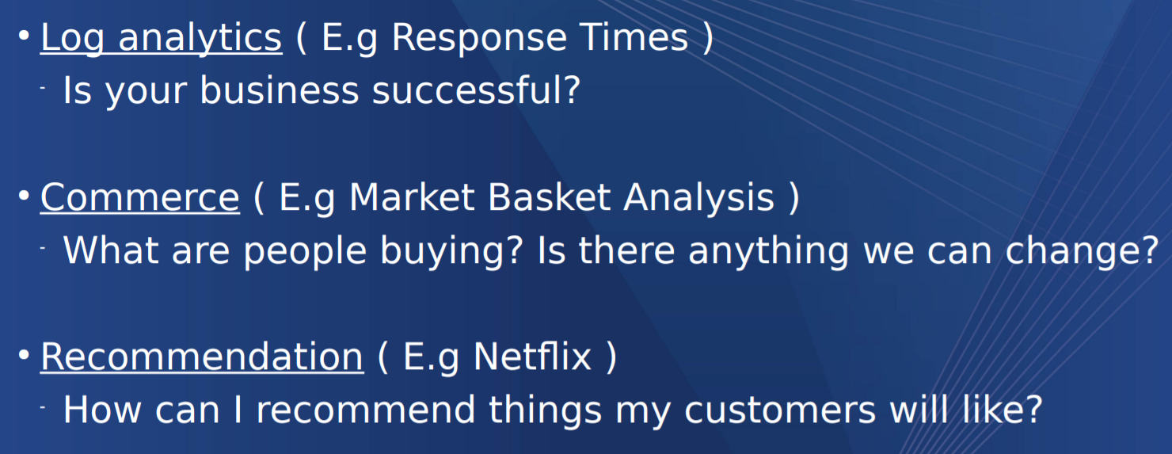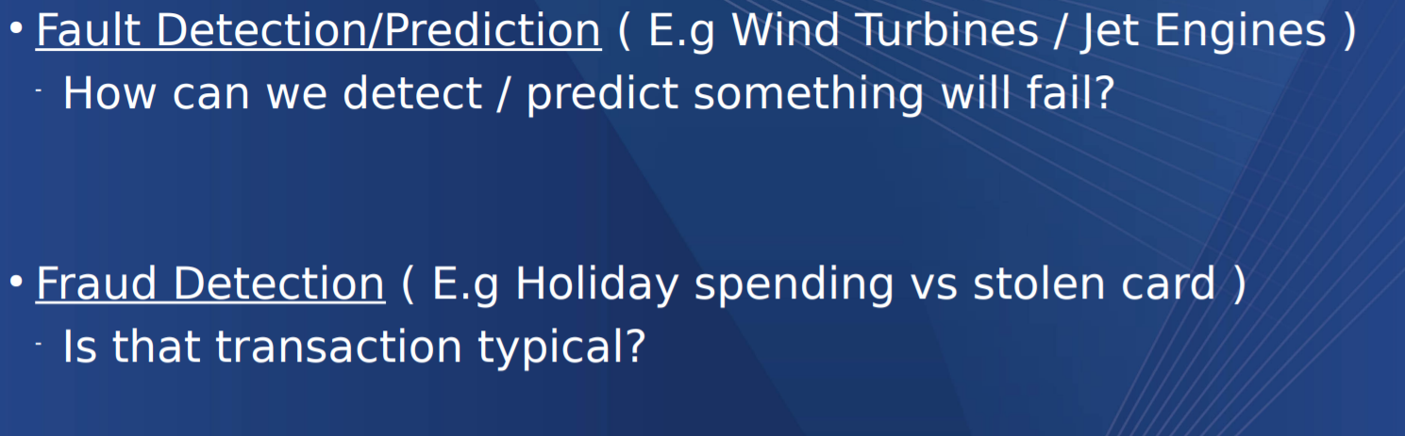

Data mining is making use of data to conclude or answer a question

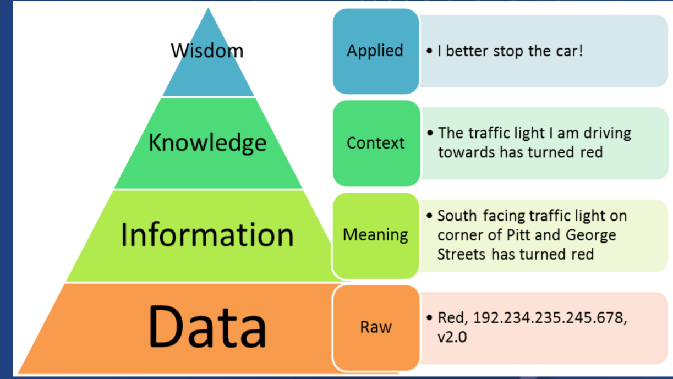

# Methodology (CRISP -DM)

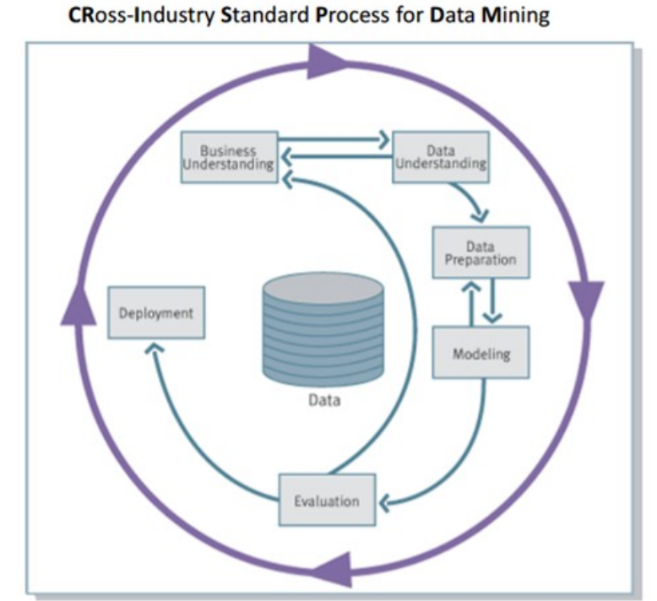

CRISP-DM Is the standard and holds 43% of the marketplace

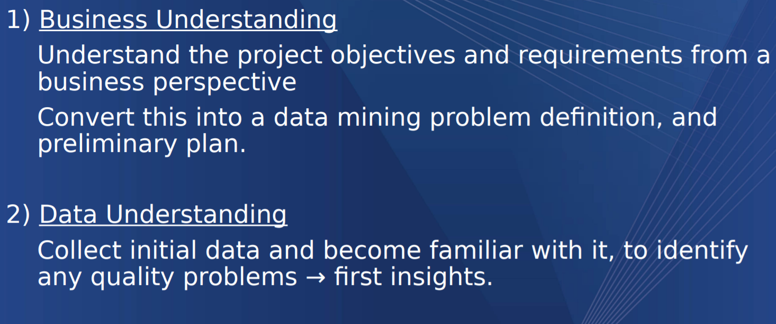

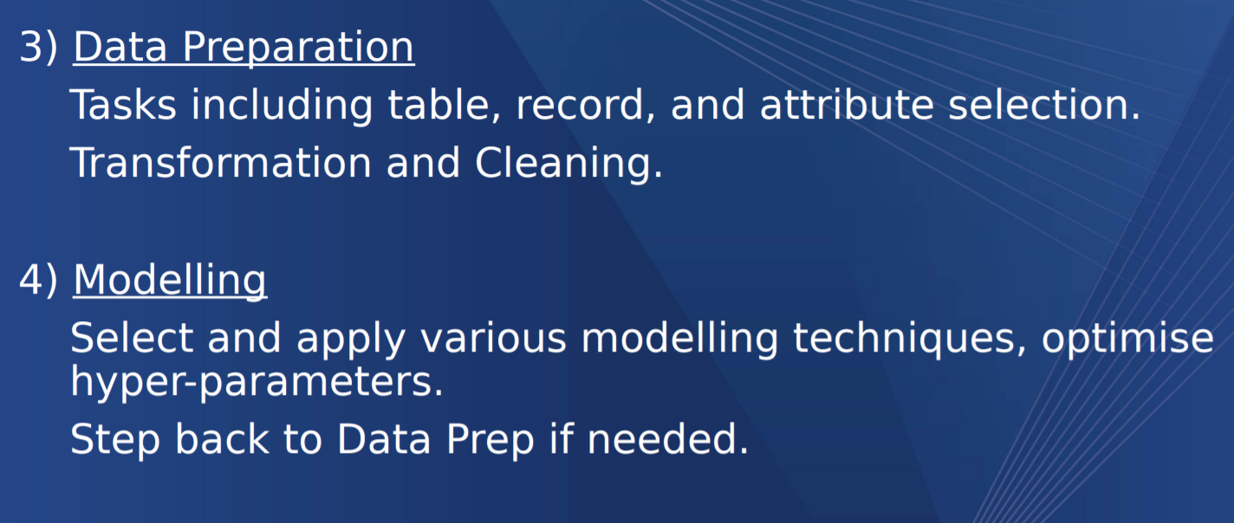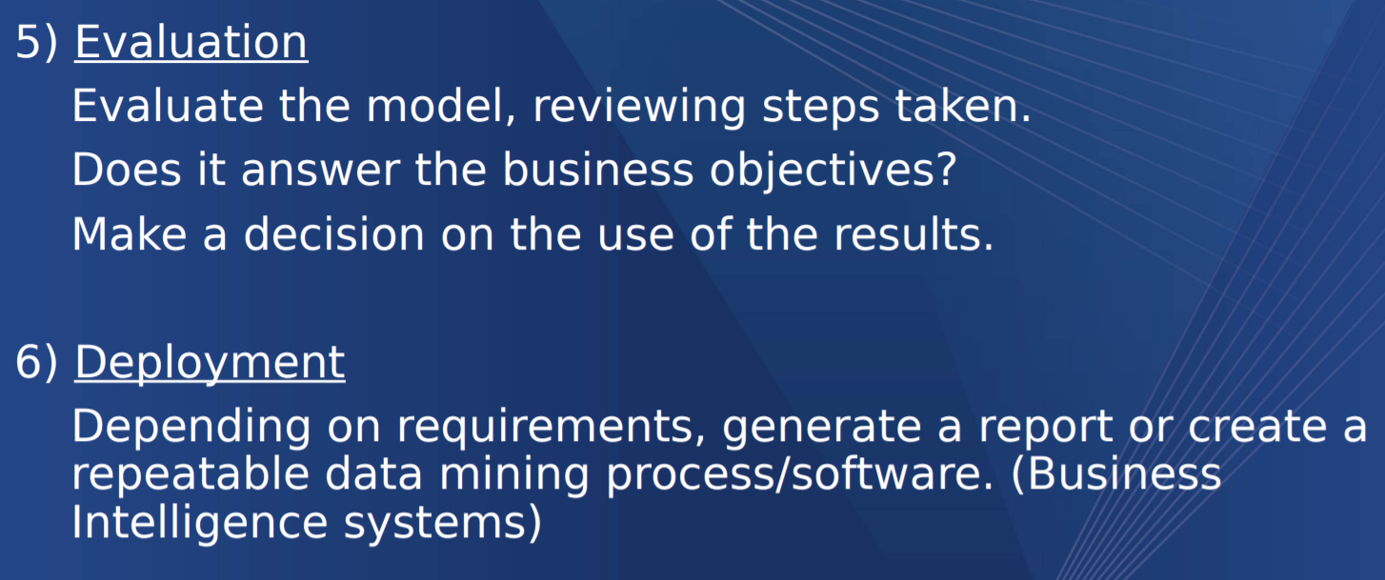

# Where do we store data?

Data is stored in a big database called a data warehouse, from here a business can operate all te relevant commands

This can be represented in many data types

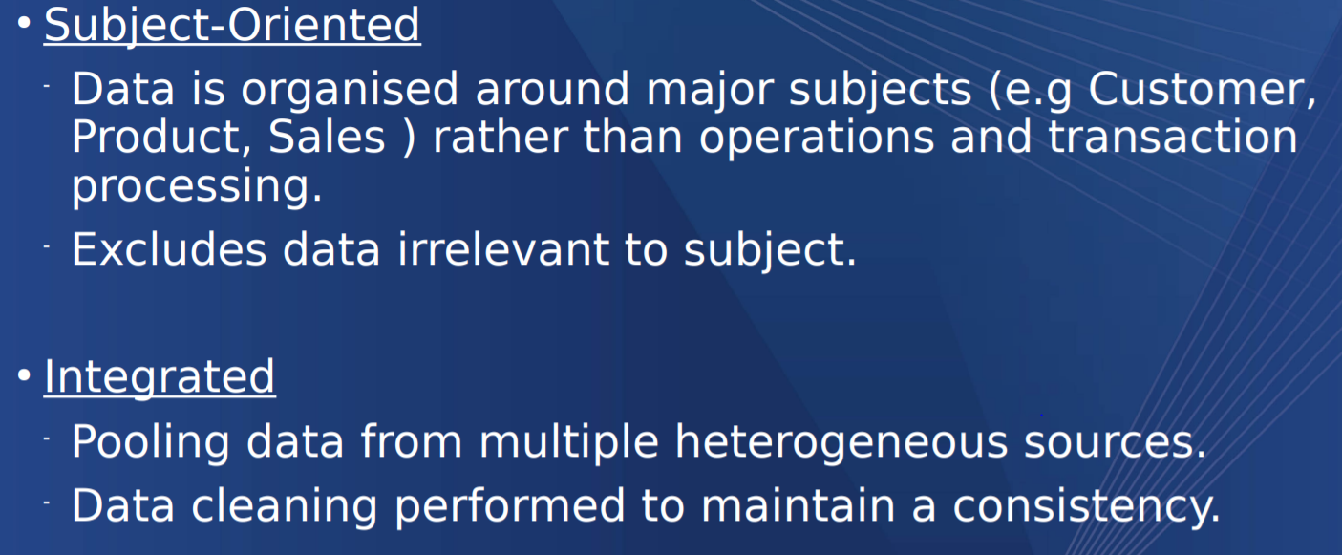

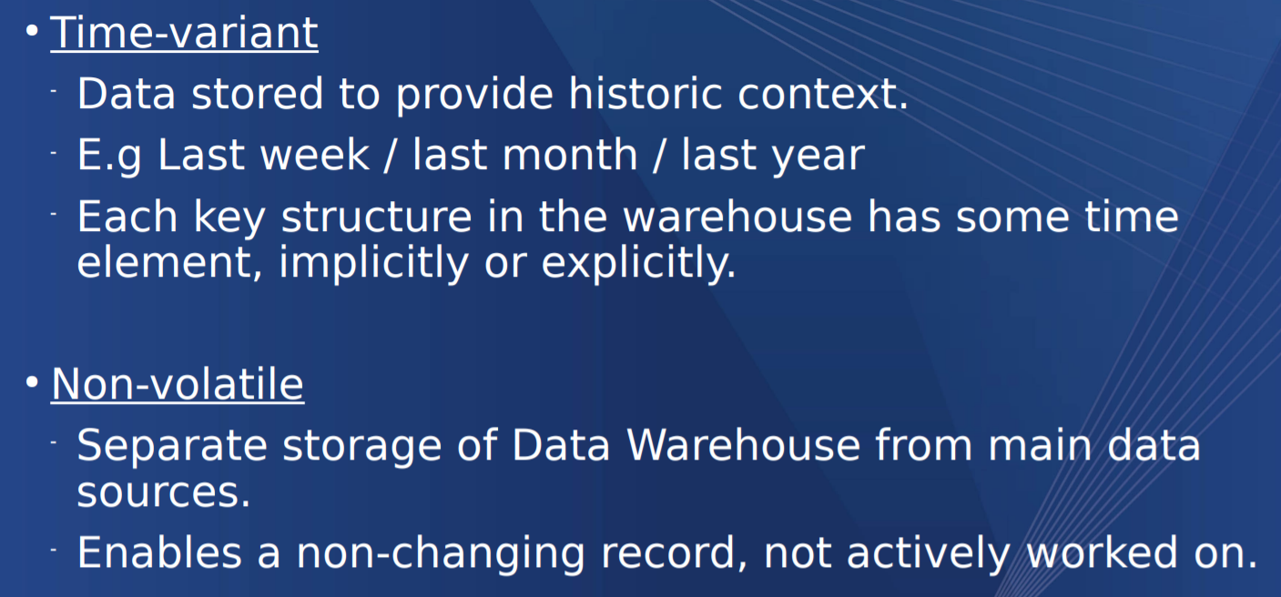

Legacy systems such as pen and paper or user spreadsheets tend to be too “Dirty” as they can introduce errors that would be detected through a database/data warehouse. This could be human error such as inserting an incorrect value or submitting a form that a database might say is null.

Other issues occur in data representation where things may slightly differ for example, house names. A house can be given a number



With that in mind there are data types which a data warehouse/database uses in Data Mining

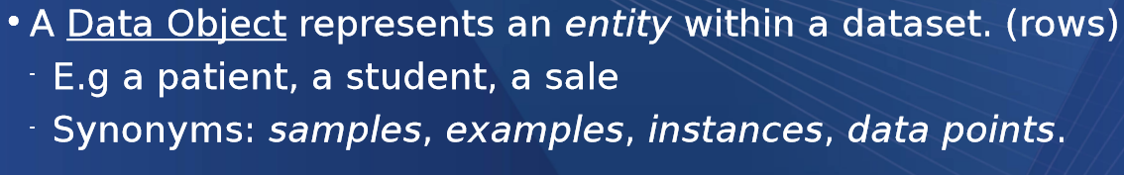

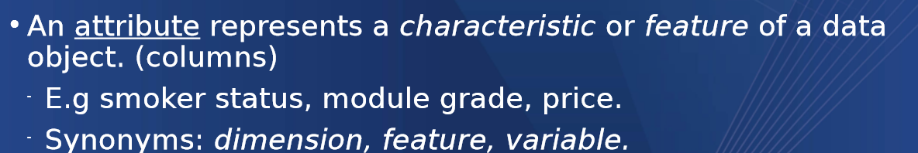

This can be measured mathematically as part of a set

A = [A1, A2, A3 ]

A car has wheels

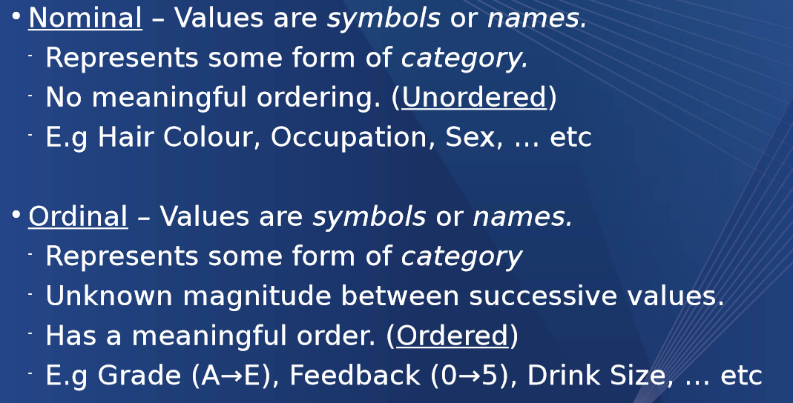

Ordinal normally requires domain knowledge into the subject however some may be quite explicit in their ordering for example small medium and large

## INCLUSIVE AND EXCLUSIVE ATTRIBUTE DESCRIPTION

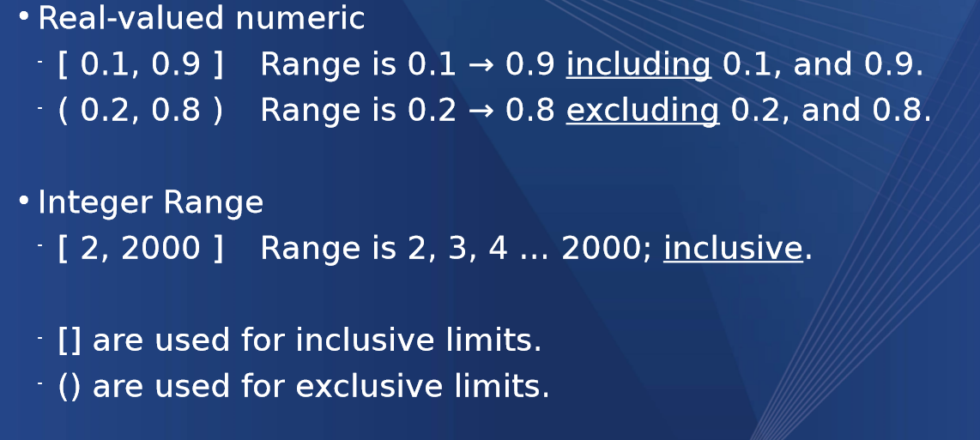

## SET DESCRIPTORS

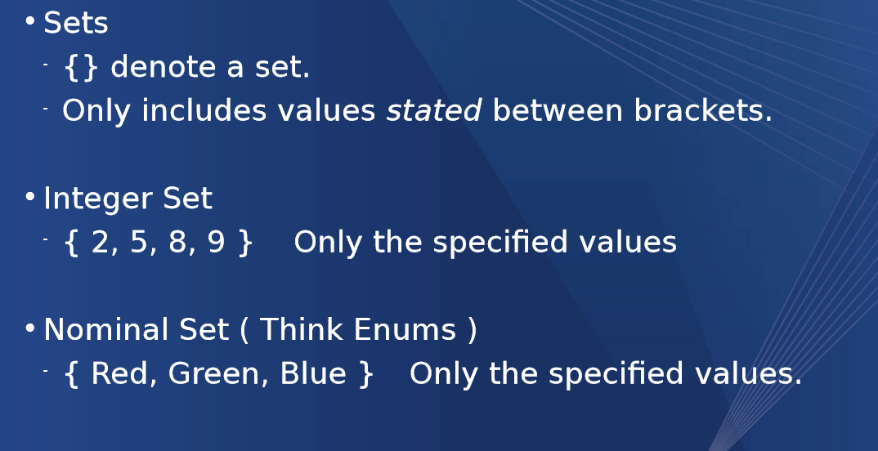

# Finding all patterns in the data (Possible Combinations) MULTIPLICATIVE SUM

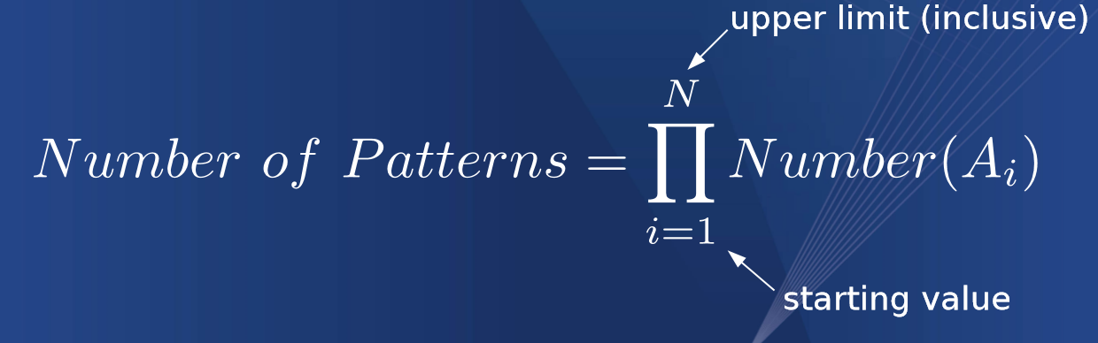

Also known as times all of the possible combination together, this defines the search space of the data

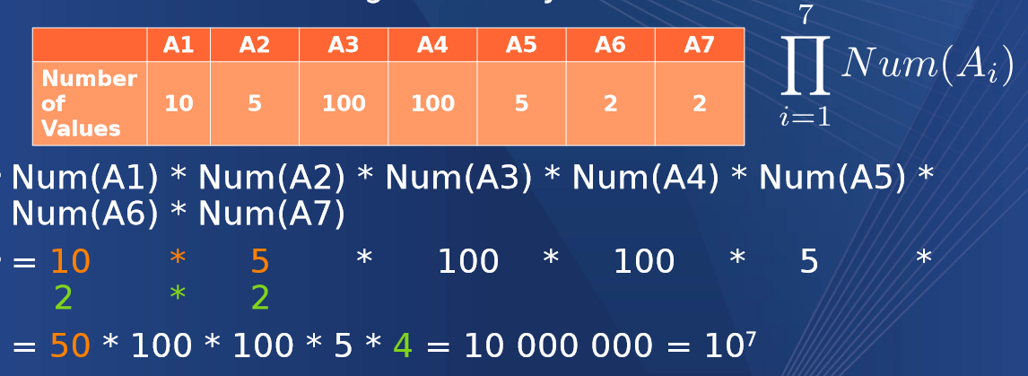

Adding more data types can double the space

Adding a simple Boolean doubles the space

# STANDARD DEVIATION = FINDING HOW FAR AWAY FROM THE MEAN YOU ARE

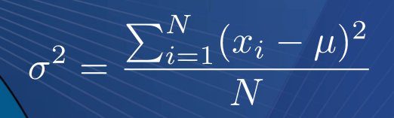

U = mean

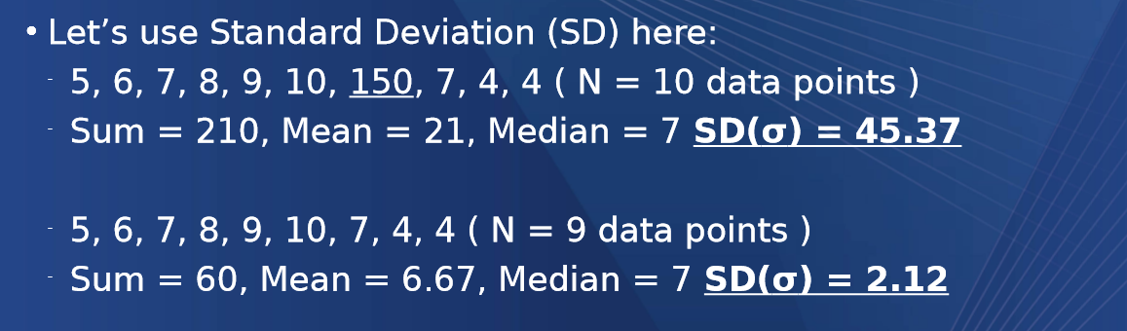

<https://www.khanacademy.org/math/statistics-probability/summarizing-quantitative-data/variance-standard-deviation-population/v/population-standard-deviation>

Standard Deviation is the square root of the variance

Variance is worked out by taking the mean and minus-ing it from the OG number then squaring it and diving all by the number of items (Just like mean)

Like to call this advanced Mean

(A – M)2 +(B-M)2 + (C-M)2 /3

Square root of this is standard Deviation

# Correlations

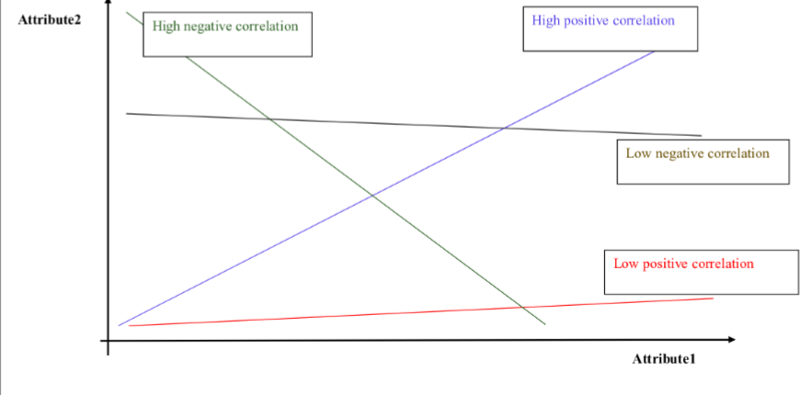

Should probably study this but I doubt it will come up

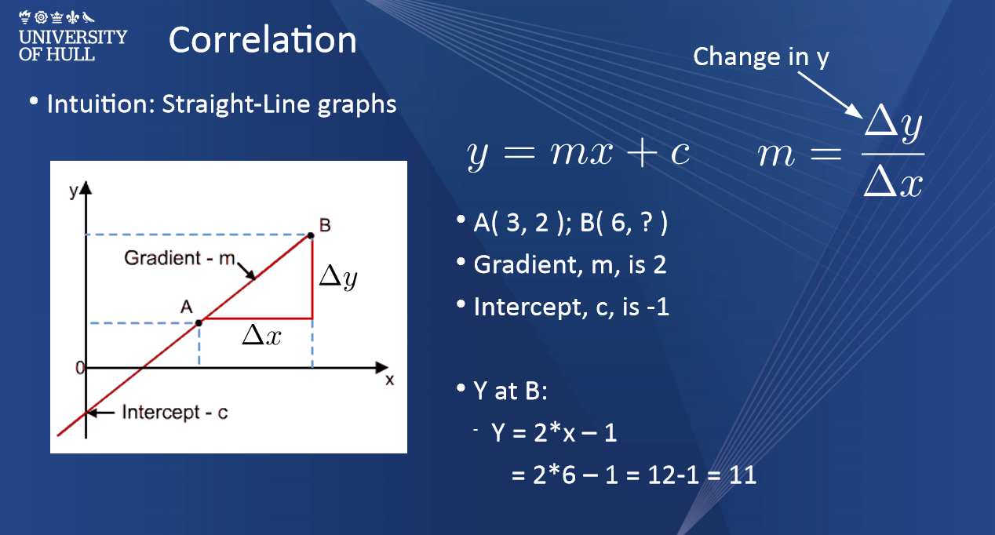

You can do a correlation table to measure the correlation between the attributes

High numbers (Green = high correlation)

Low numbers (shades of red = low correlation)

It’s a positive correlation if X increases and Y increases and a negative one if X increases and Y decreases (vice-versa)

# Regression

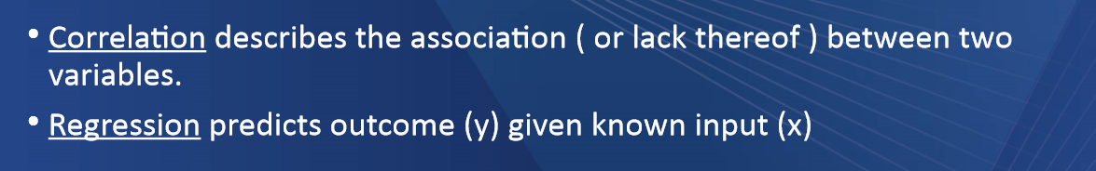

## Calculating linear regression

Y = MX + C

Y = M * X + C

## Multiple linear regression

Y = M1 * X1 + M2 *X2 + C

# Data Similarity

Having data similarity is good because it allows us to compare objects numerically. Two fruits may have a similar due to their attributes, colour size or taste

The more attributes you are comparing the more space required to be in existence, similar to search space in multiplicative sum

The number of dimensions depends on the amount of attributes

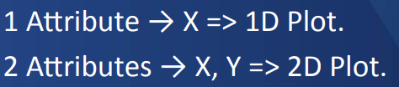

## This is referred to as n-Dimensional for n number of features

Jaccard similarity

Intersection over the union

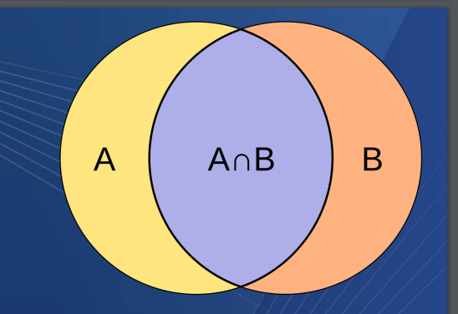

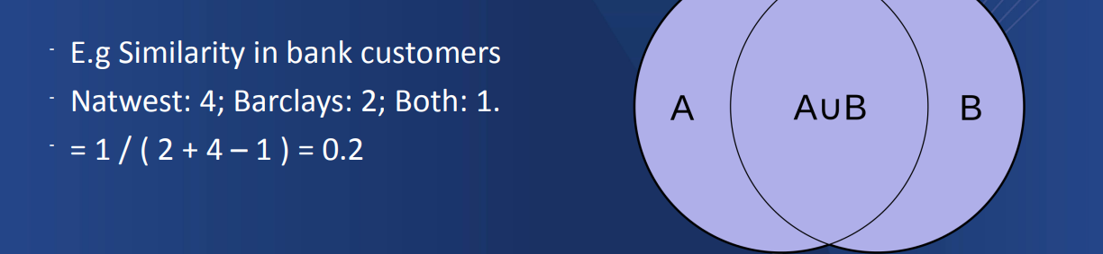

# Euclidean distance

Measures similarity (Dissimilarity)

Based of Pythagoras theorem

A2 + B2 = C2

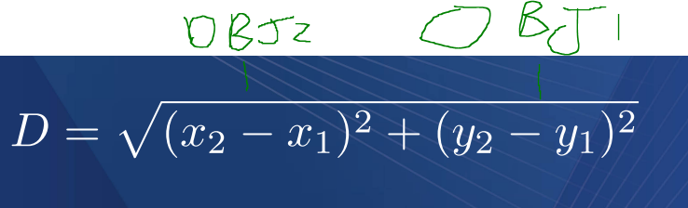

Measures distance between 2 objects which helps you measure similarity

Take objects

A = x = 5 y = 8

B = X = 7 y = 9

5 – 7 = -2

8 – 9 = -1

-1 ^2 = 1

-2 ^2 = 4

Square root of 5 = 2.2

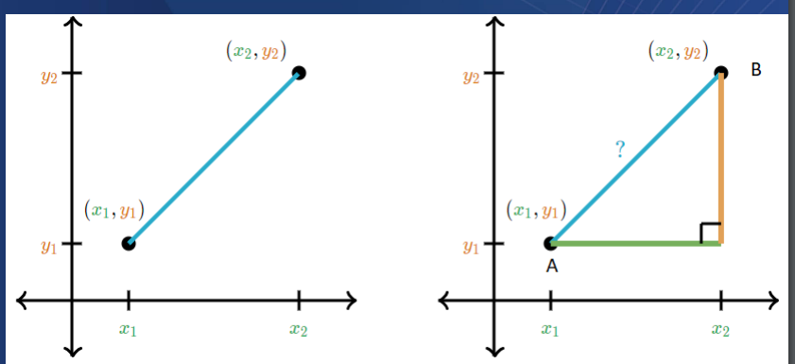

Alternatively, Manhattan distance is the absolute value of this not square rooted

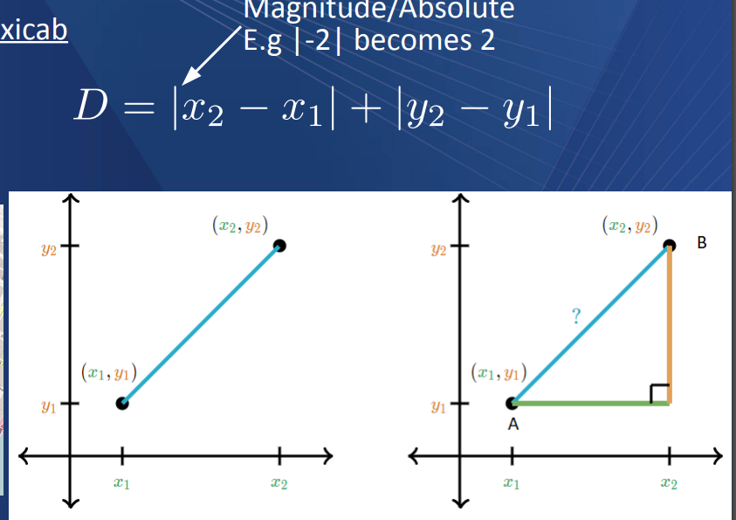

# Normalisation

Makes values between -1 and 1.0 or 1 and 0

This allows for differing amounts of data to be compared

10 frogs

1000000000 tadpoles

This could not be compared normally because the number of tadpoles would skew the frogs

Normalisation solves this

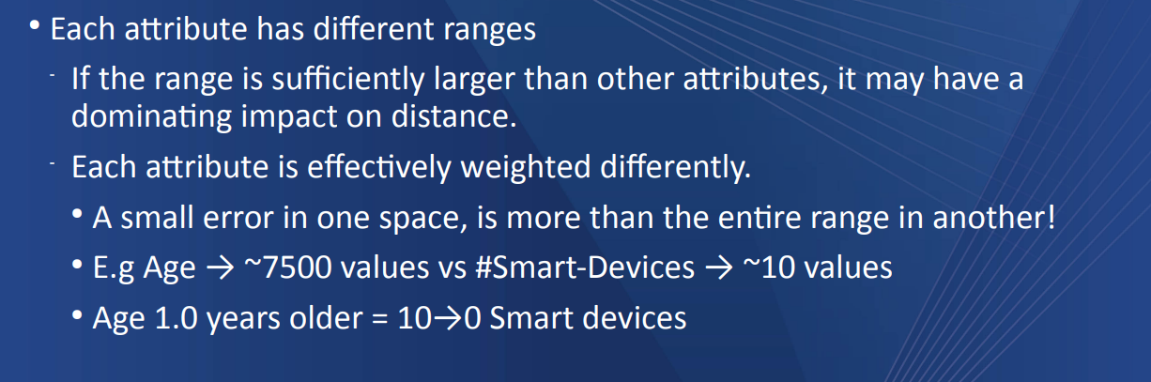

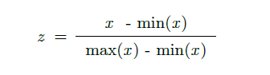

Value – Min of value / Range of value

# Standardisation

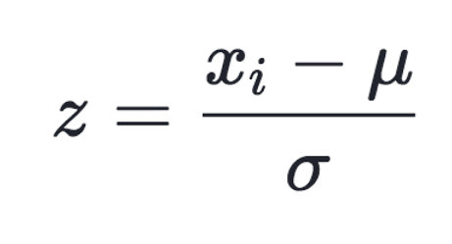

Number – Mean / Standard Deviation

# Data cleaning

Look at data and do an inspection on it

Ull vs Hull

Nwrk = is this new York or Newark

So how do we check for duplicates ?

Bad way, Check each one in an if statement

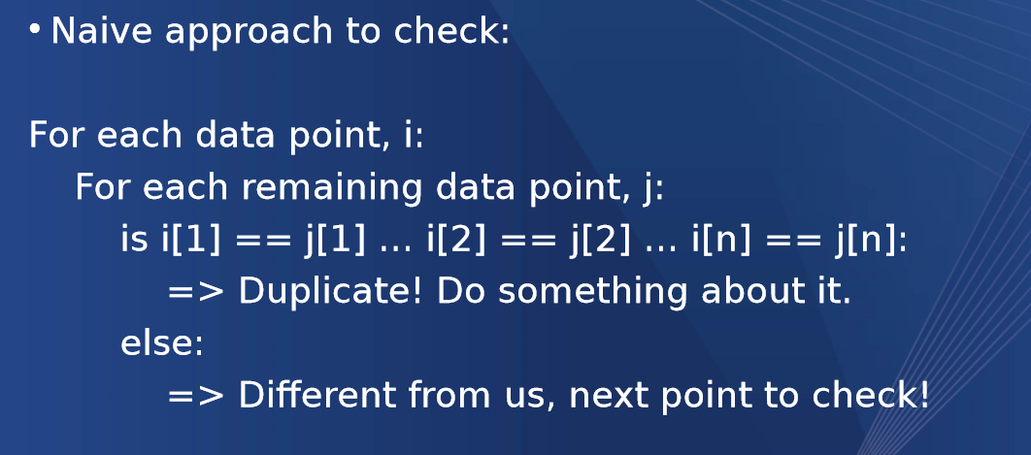

This is ok for small amounts of data but for big bois its shit

Unique identifiers help to determine what is a duplicate and what isn’t

This is however dependant on domain as someone might move to a new apartment every year, which is the most up to date version

Combinations of attributes are often used to get a direct UID (composite primary key)

Imputing data

# Removing or clearing null values

How do we know what data is null/missing should be?

Use known data to estimate what something might be

Use linear regression

The data might be

global – all values of that attribute are considered // mean

class specific – based on an outcome (mean age of those who survived)

Sub class specific - based on an outcome and additional criteria (mean age of those who survived where economic status = 3)

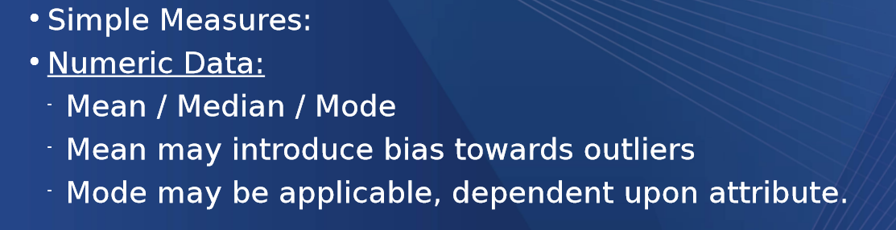

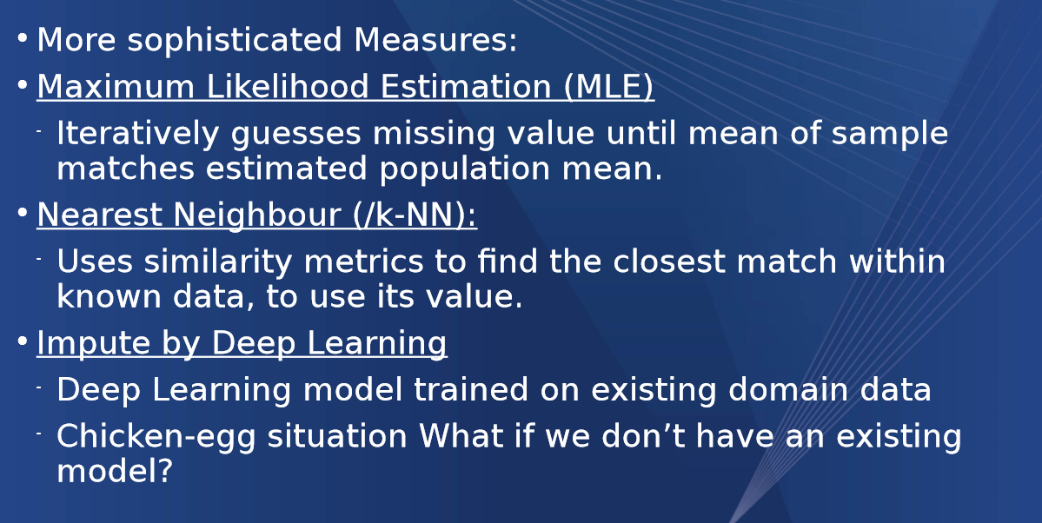

# Calculating Hughes phenomena

Hughes phenomenon is about finding the valid data points in the solution using multiplicative sum to find the valid points. Generally as you increase the search space your data gets more accurate and you get more valid points for the model but the more useless features you add the bigger the search space gets therefore worse data accuracy

Example 1

Step 1: Calculate search space

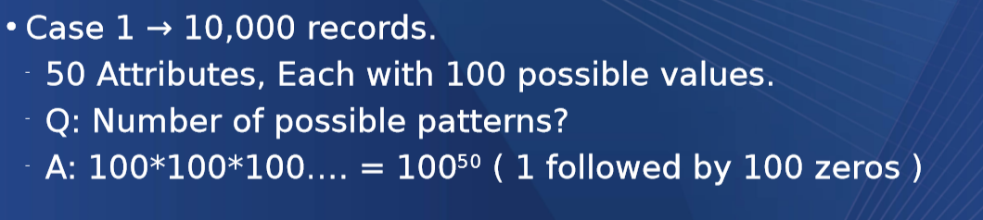

Step 2: Calculate using the amount of records the possible unique data points

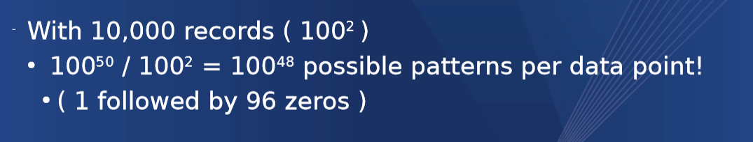

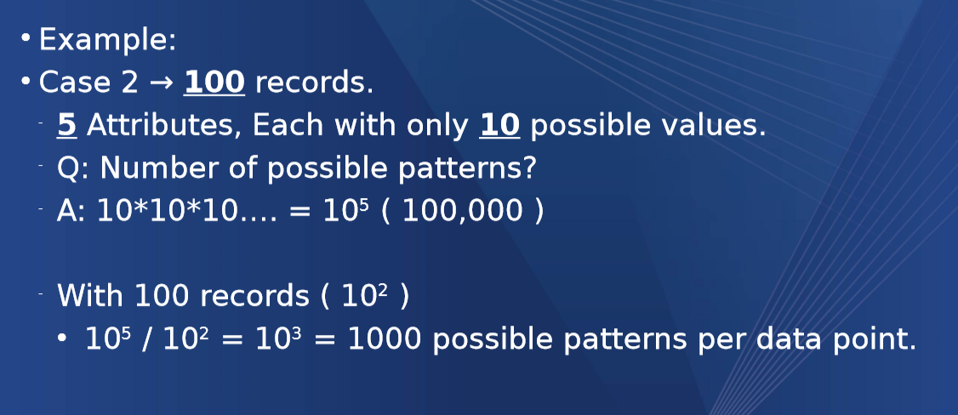

You can then start eliminating illegitimate data points and get a smaller search space for your model

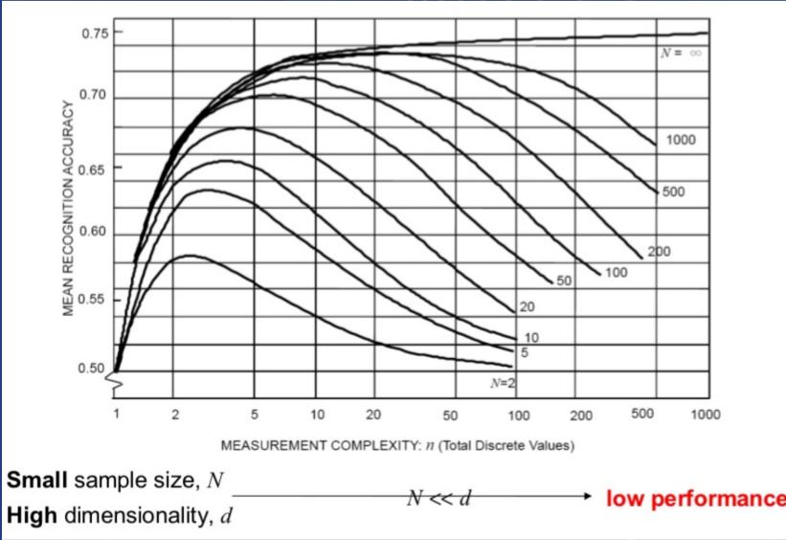

This creates a way when you add more features to your search space the accuracy increases but the useless space also increases

How to eliminate more results from our search space

## Filter by variance

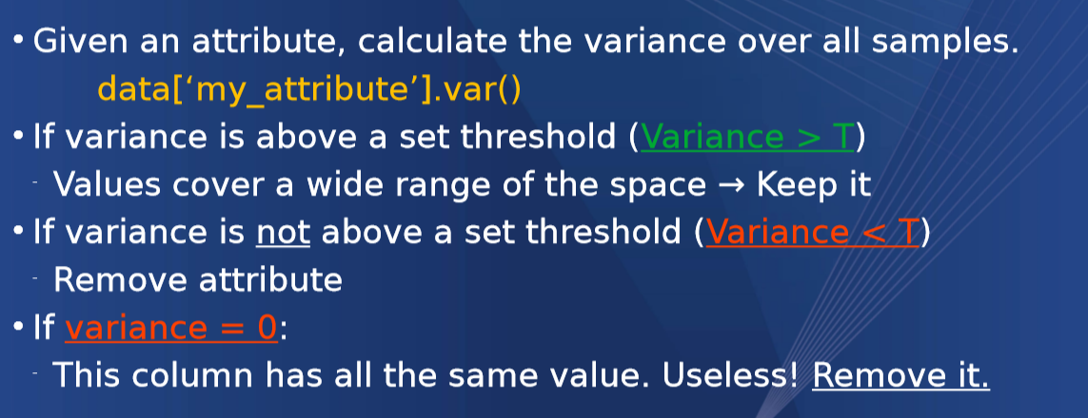

## Filter by Correlation

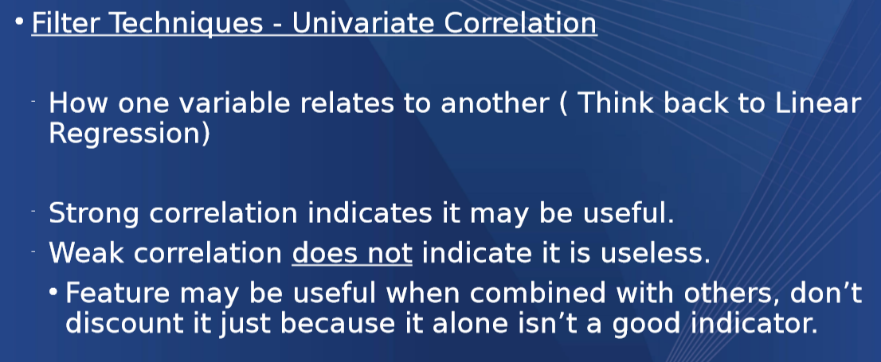

## Find a Subset that is best for your model (A lot of different outcomes and a lot of computational power)

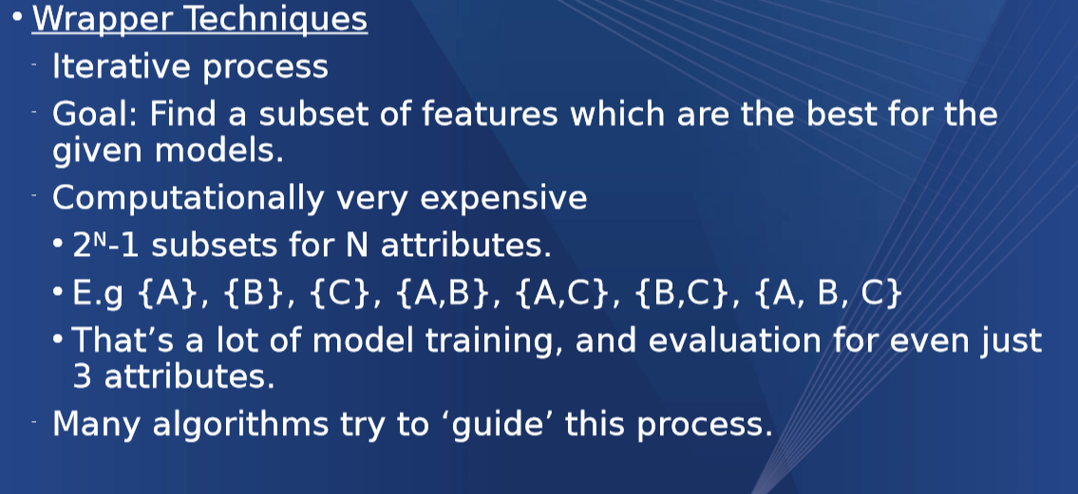

# Shrinking the space by grouping

If something is to a decimal place you can round it to shrink the possible outcomes

We can shrink to midpoints

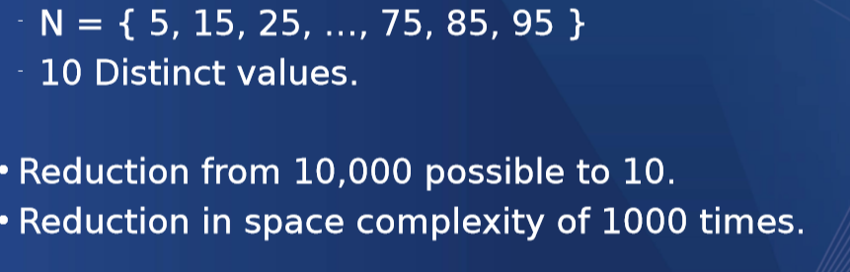

Shrink to specific groups



If 2 values are strongly correlated, we can replace them with 1 value

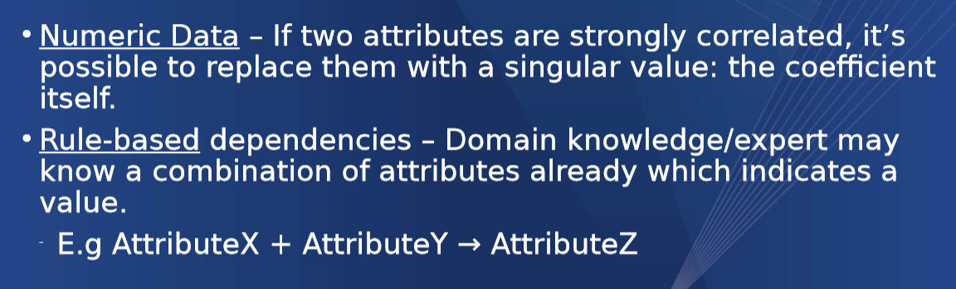

# Dummies

## One Hot Encoding

Turns a nominal value into a Boolean value

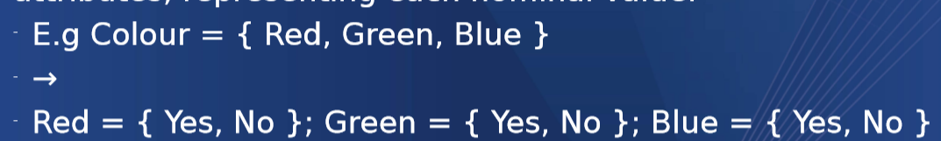

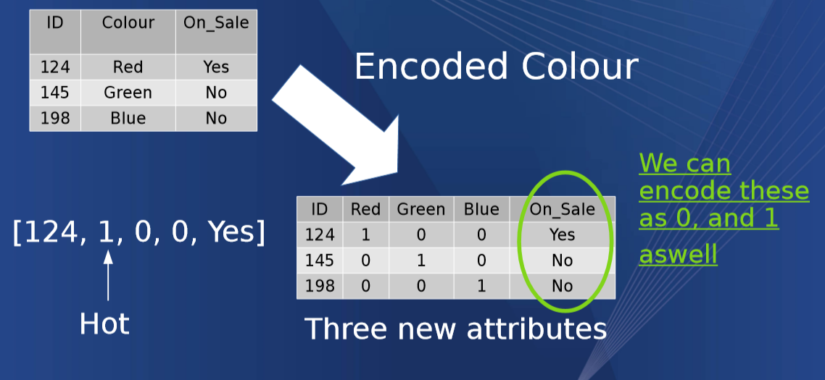

# Types of Visualisation

## Histograms (Bar Charts)

Represents a single attributes frequency

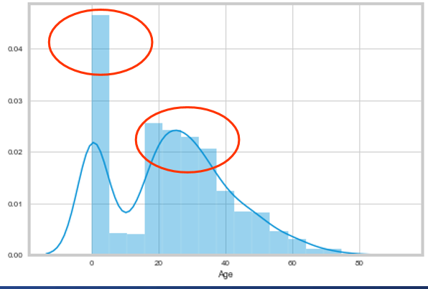

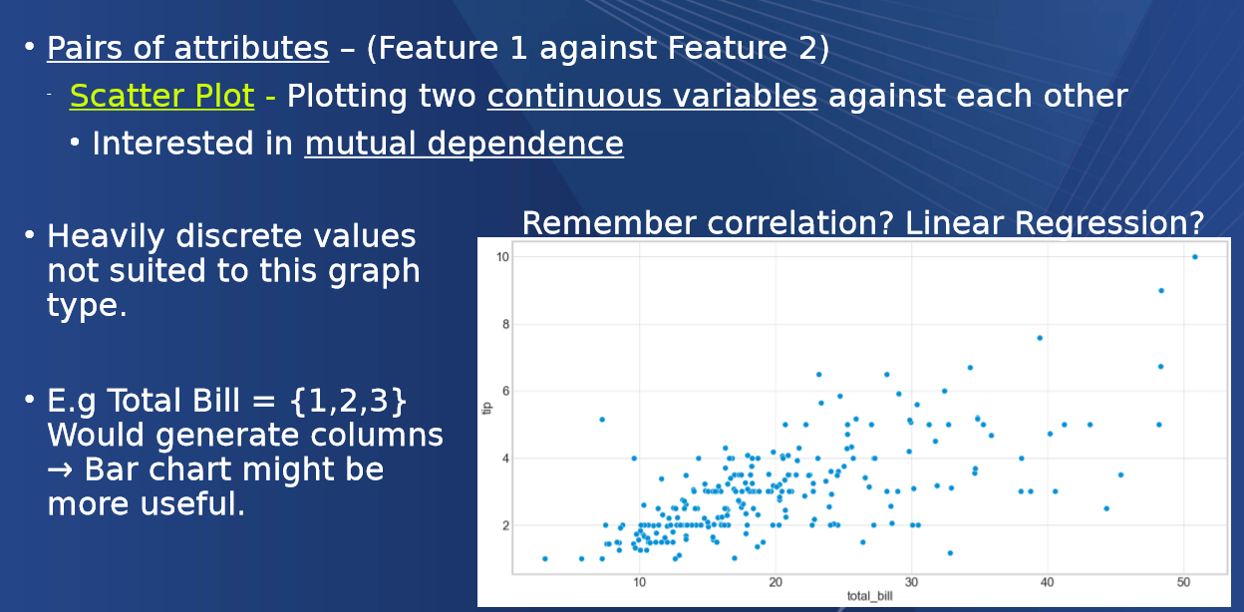

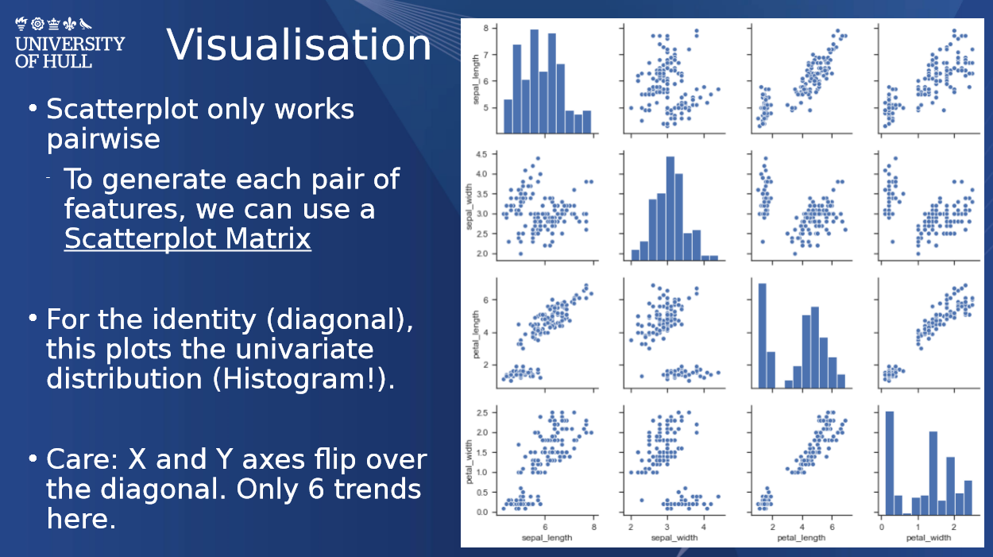

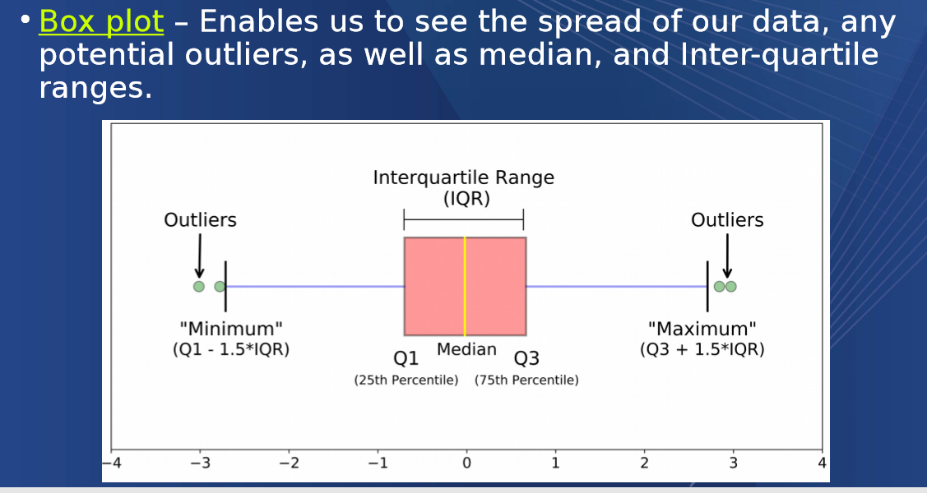

# Models

Regression Models – Outputs a real valued variable

Usually fitting a line

Classification – categorisation of data into pre-defined classes based on input data

Patient at risk or not at risk

Gun type: SMG, Pistol, Shotgun, Revolver

Linear classifiers

Y = MX+C correlation (Linear regression)

Nonlinear classifiers Curve

Y = M E^x +c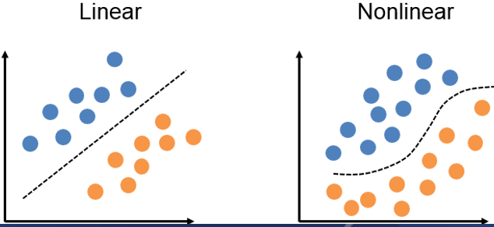

Your model cant be 100% Accurate so to structure your model you have to be careful about the erroneous data points that you may come across in your data. This can be measured by the mean square error and the mean absolute error (which always come out to be the same value) 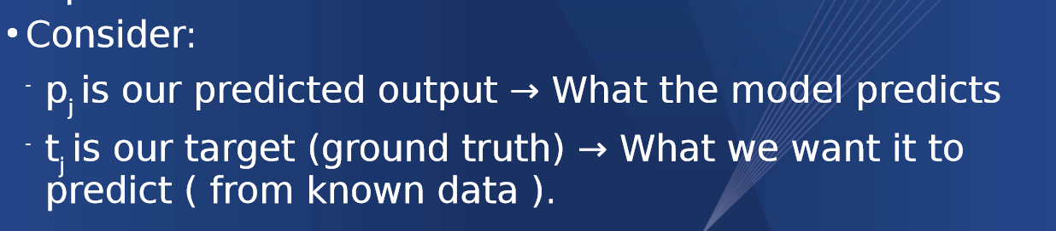

## Mean squared error

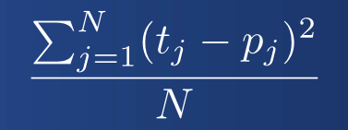

Mean Absolute Error

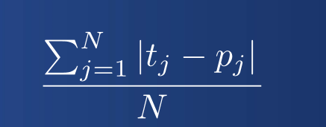

## Other methods (maybe don’t need to know )

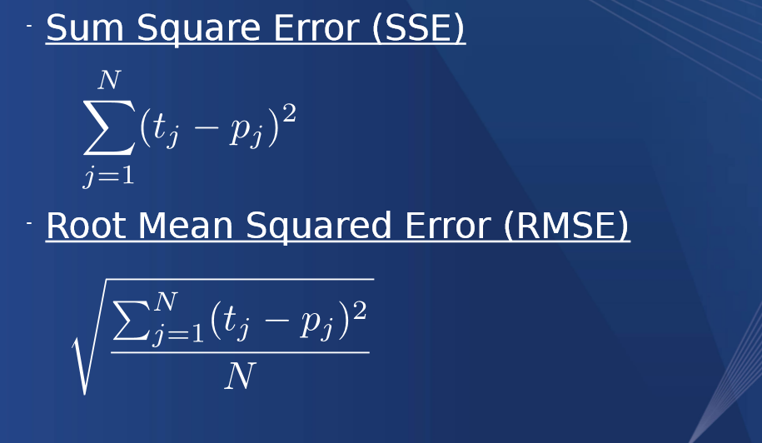

# Confusion Matrixes

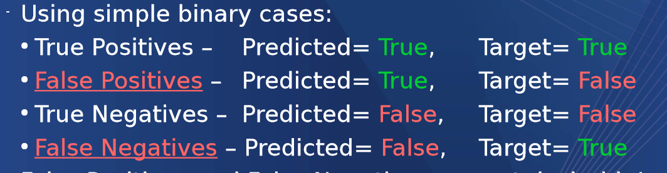

Accuracy of the Model is the number of correctly classified data points as a percentage of the whole

Additional stats can be created to measure this rate.

Sensitivity – true positive rate

Specificity – True negative rate

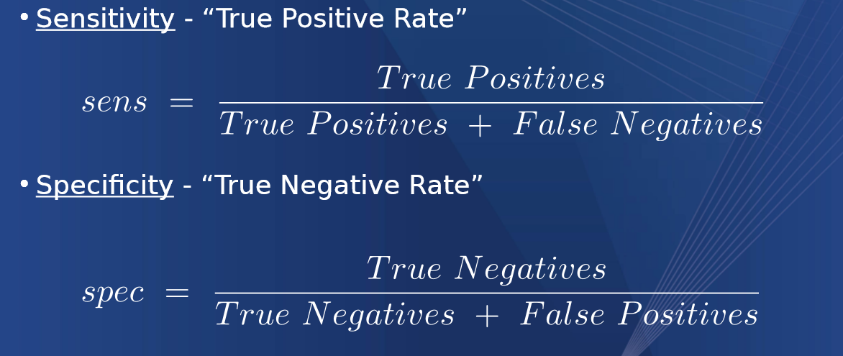

The opposite of this are below

Precision - Out of all positive predictions which where right



Precision – out of all the positive targets which to we accuracy predict

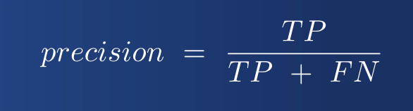

If we have a dataset you can iterate through the seet against our model tyo find all of the states the model predicted that will help us draw out a confusion matrix

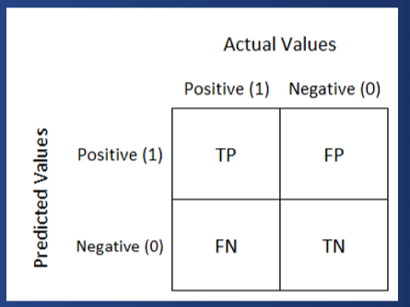

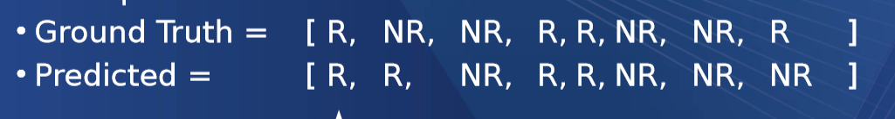

TP, FP,TN,TP,TP,TN,TN,FN

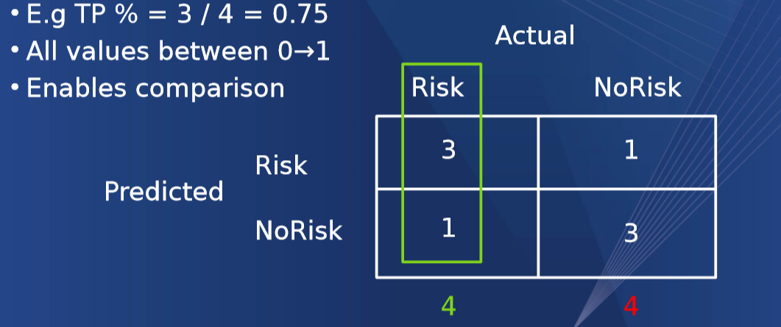

This can be normalised as a percentage of 1

E.g TP % = 3 / 4 = 0.75

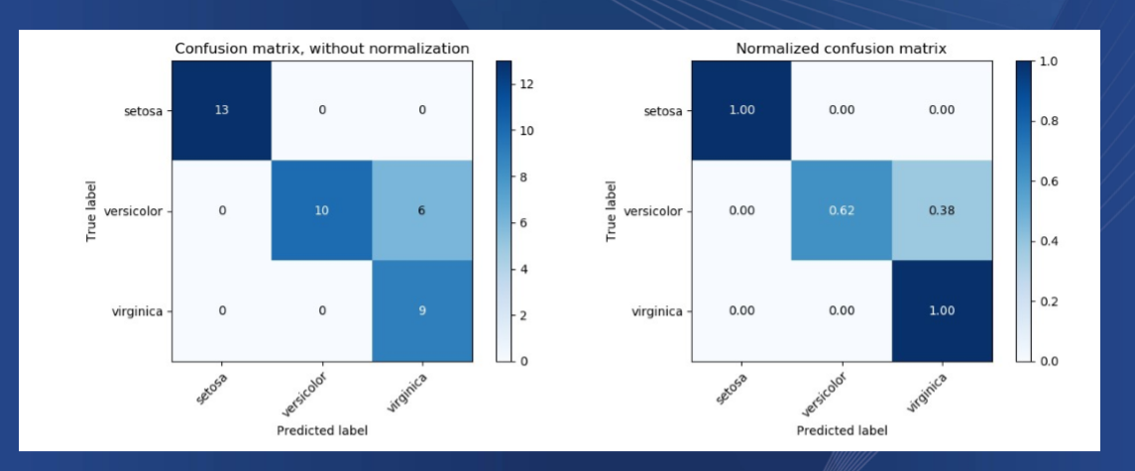

# Model training

Must be done on unseen data

Data is split 70% to train 30% to test q

Where does to split take place?

What if all the useful patterns for training are at the end?

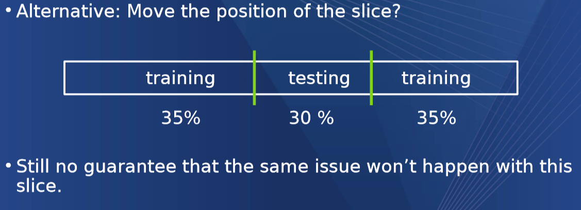

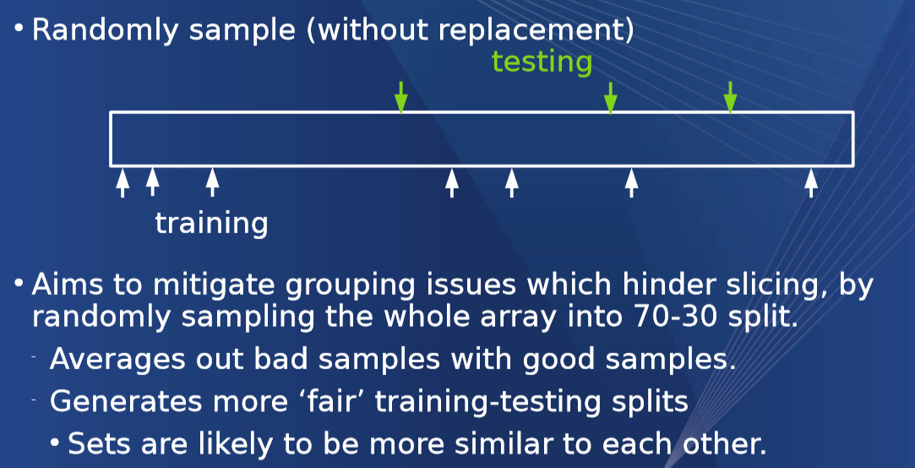

## K-Fold Cross Validation

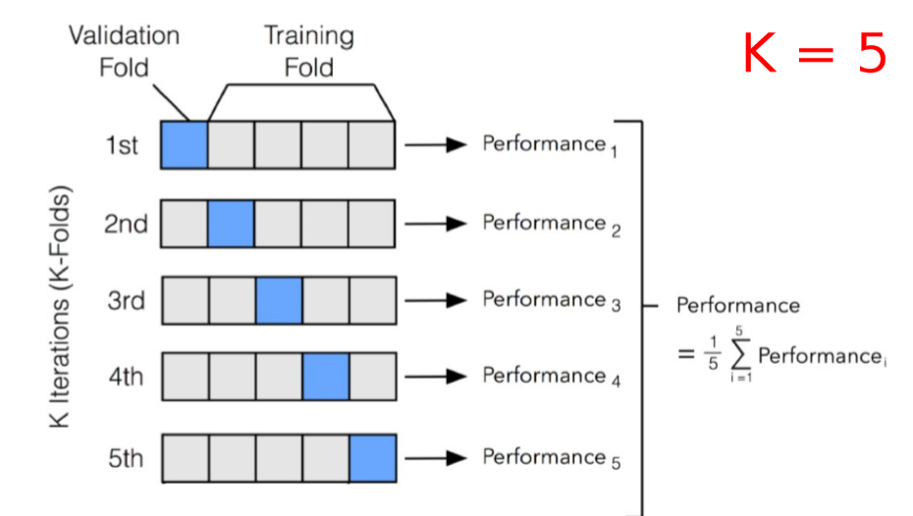

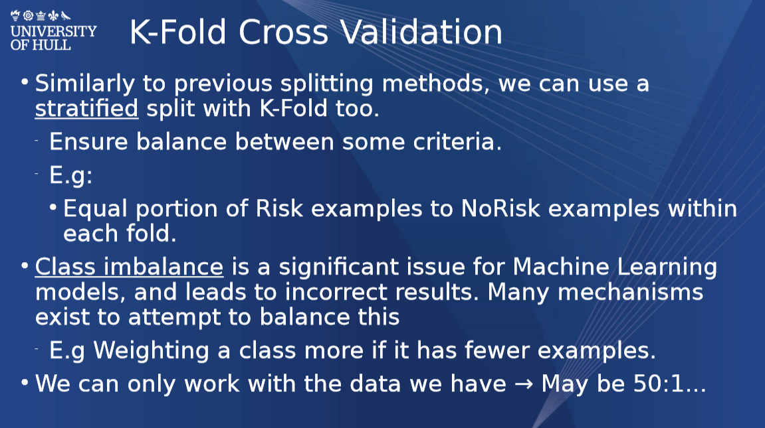

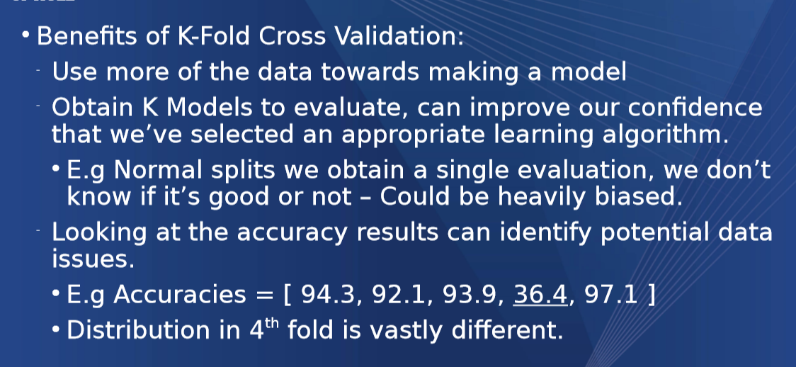

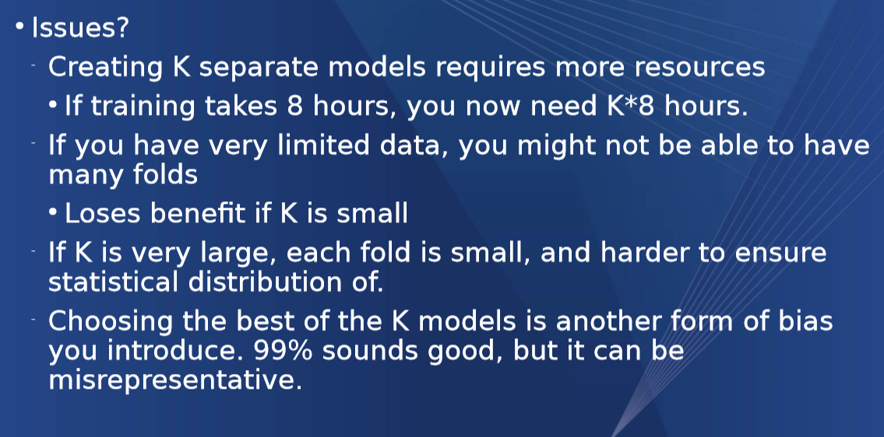

# Overfitting

Where the model tries to fit too close to the data and therefore causes errors when it runs into real world data

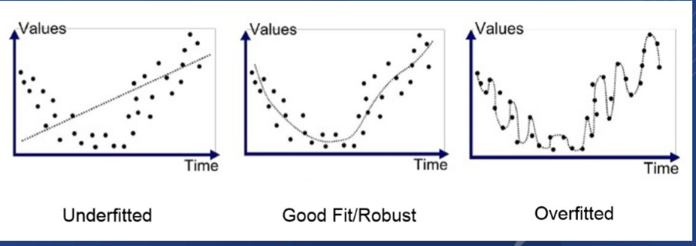

Testing for overfitting is simple

If training accuracy is 99% and the testing accuracy is 20% the model has probably been overfitted

# Decision Trees

A decision tree is a model that aims to recursively partition the data bases on attributes

Multiple algorithms exist for constructing/training a decision tree

CART

ID3

C4.5

C5

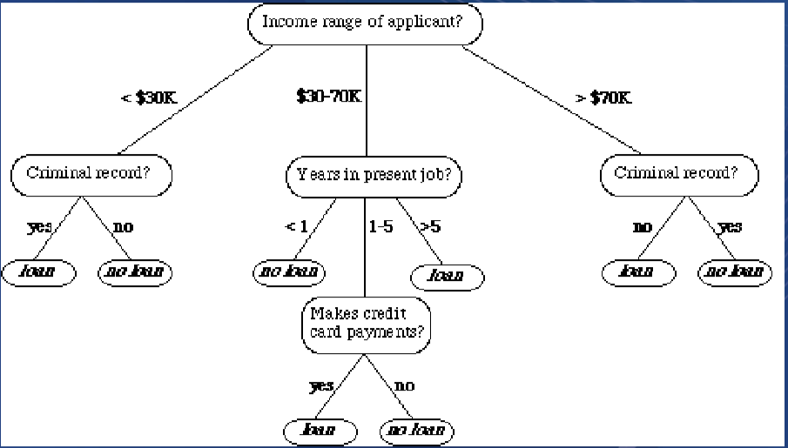

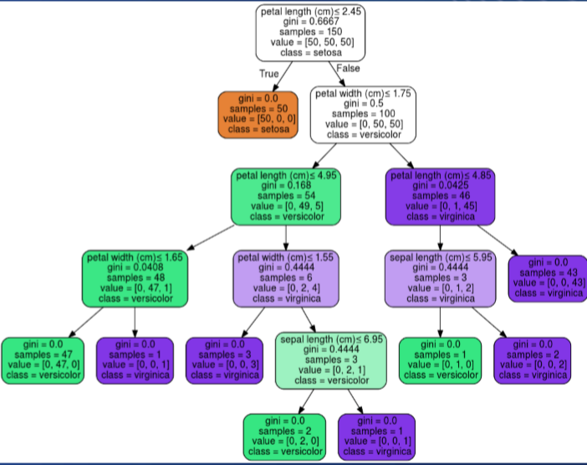

CART = Classification And Regression Tree

Implemented using Sklearn

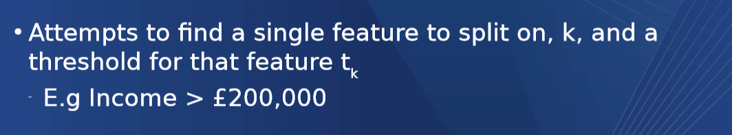

Use Gini Impurity to find the best feature

A type of dissimilarity measure

Ideally, we want splits to perfectly partition a group.

All of class A to the left

All of class B to the right

## CALCULATING GINI IMPURITY

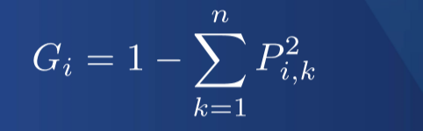

This is a bitch

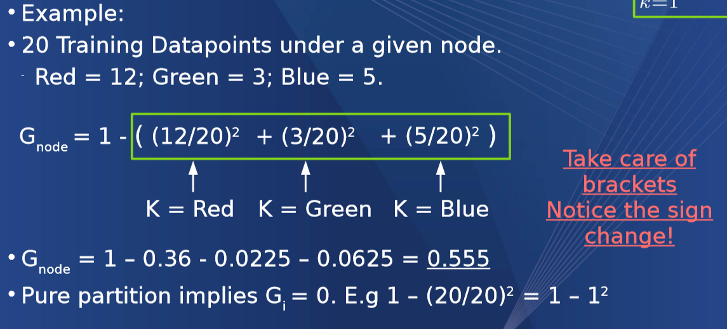

The amount of data points divide by the whole per datapoint squared – 1

## CALCULATING CART ALGORITHM USING GINI ( FUCKING AIDS)

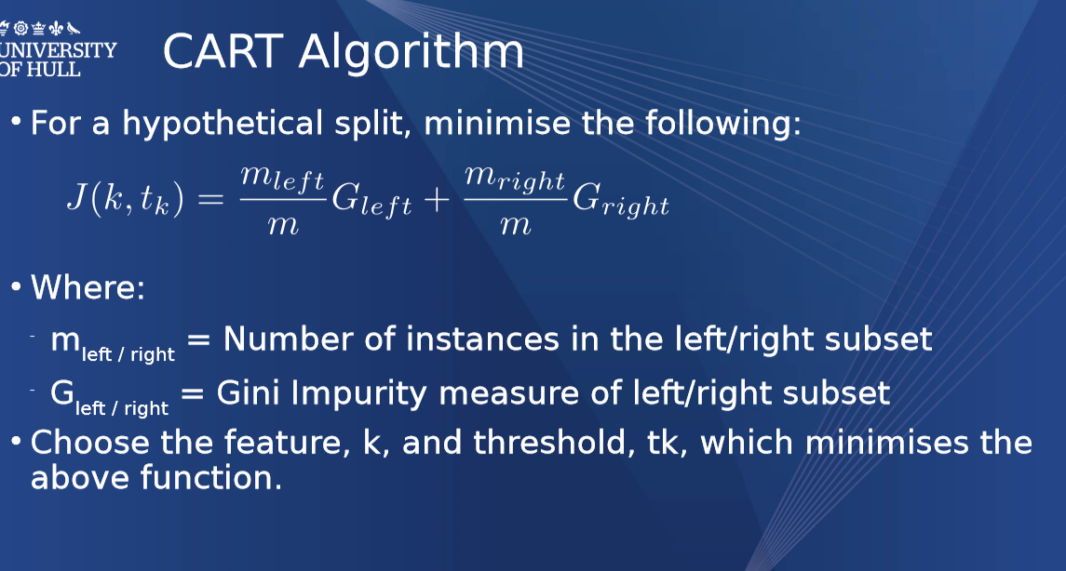

CART is a greedy algorithm which means it lives in the time and doesn’t think about possible splits later in the line just worries about where it is currently.

Its greedy as as the size of the dataset increases the computational power required grows exponentially

# Whitebox and Blackbox Models

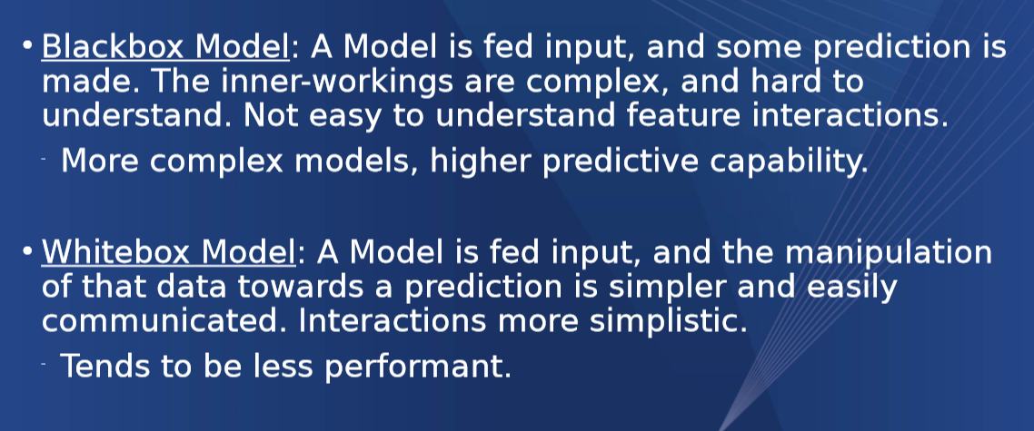

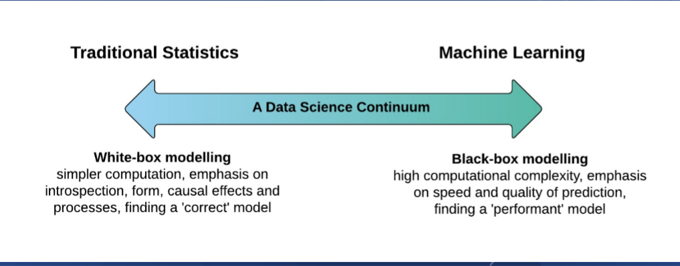

# Association Rules

Useful for marketing

Check out data in supermarkets (Diaper and beer)

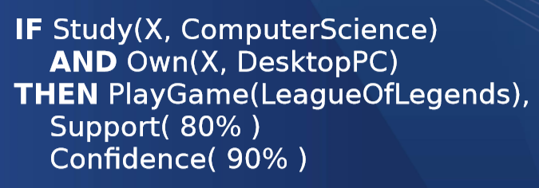

Support: % of data that contains items in the rule



Confidence: % of data containing total rule combination over data containing rule precondition



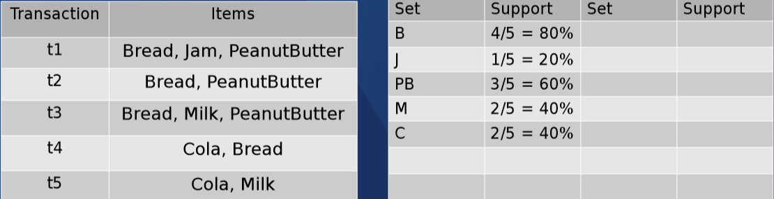

To calculate the support an item has you have to find how many times it appears in the transactions and find the percentage of that

For example

Bread appears in 4/5 transactions which is 80%

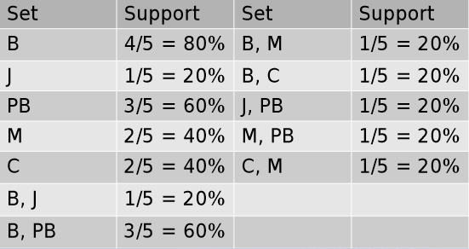

You can also find combinations of the different items but if wo items are included then the inverse of it will be the same support rating

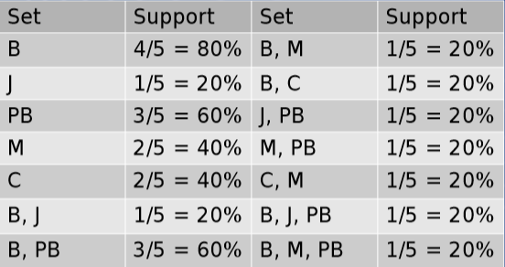

You can then find the tuples of that

## n-choose-k

to find the number of combinations we use the following

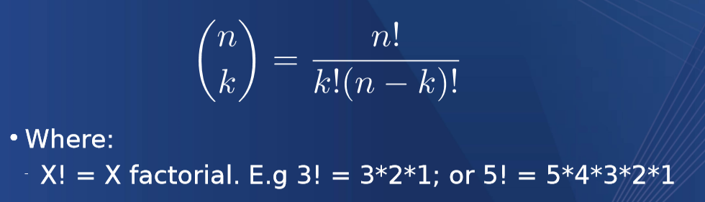

Given a number of possible items (n) and the combination max size (k) we can work out how many combinations we have

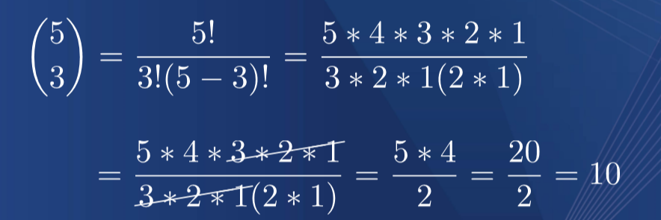

Factorials cancel out so you can do the following transaction or put the entire thing into the calculator

## Information improvement (may require Domain knowledge)

Remove impossible rules

Improvement is a measure of how much better a rule is than random chance

Probability of X,Y,Z showing up randomly is P(X)P(Y)P(Z)

P*X + P*Y +P*Z

Observed probability (where all 3 show up) P(X,Y,Z)

P*(X*Y*Z)

If the observed = the chance, observed are as good as chance

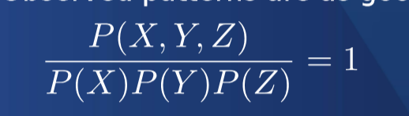

If ratio > 1 probably improved

If ration <1 Not better than chance

Improvement is measured by P*X +P*Y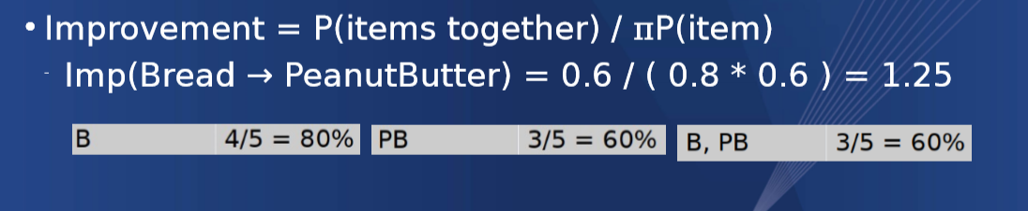

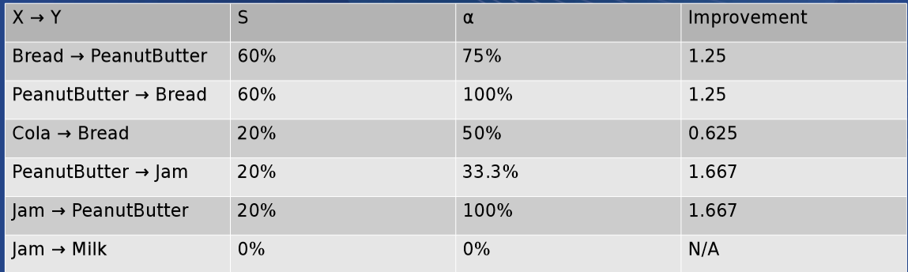

AIDS Could do with looking up

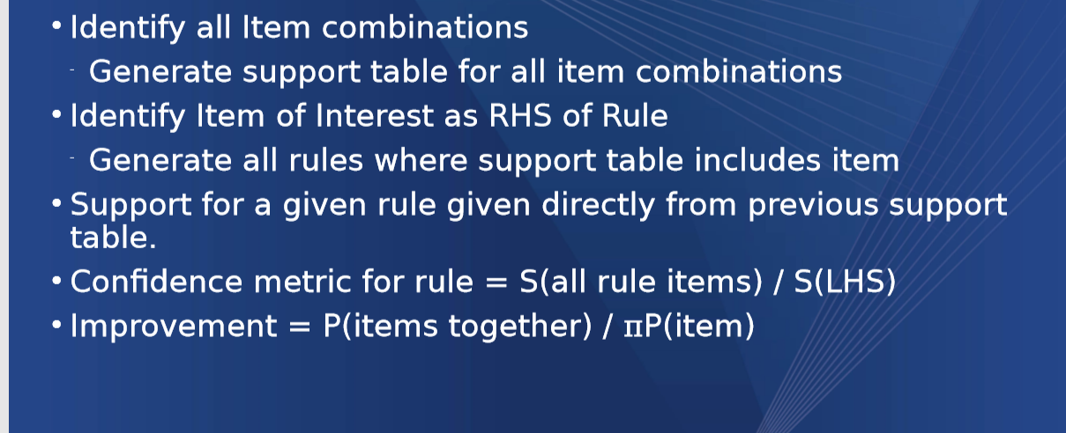

Walkthrough

Transactions

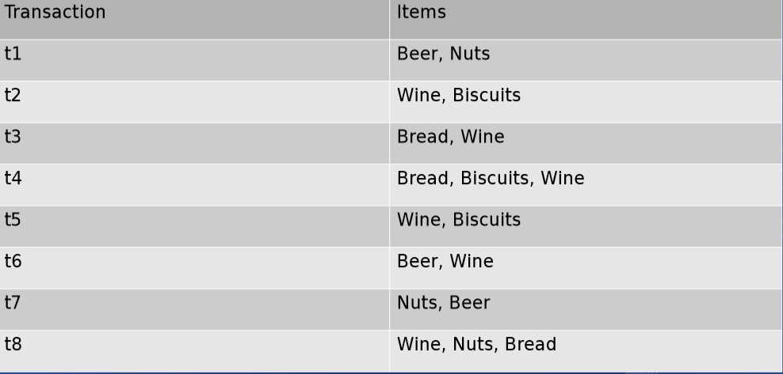

Create frequency

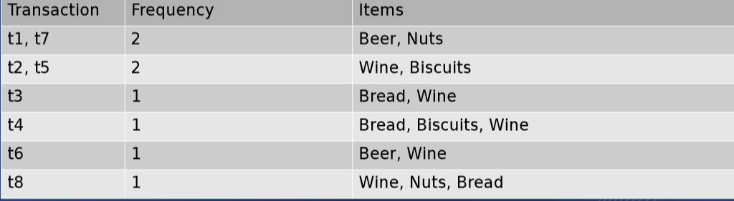

Calculate support

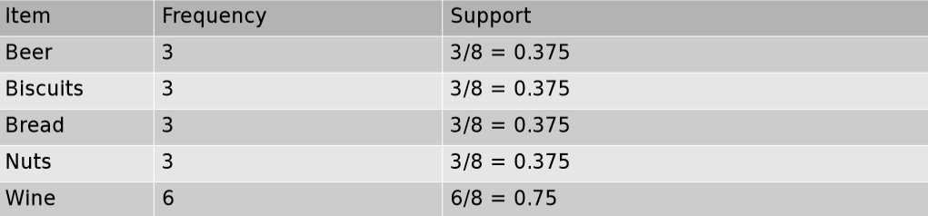

Calculate support for combinations

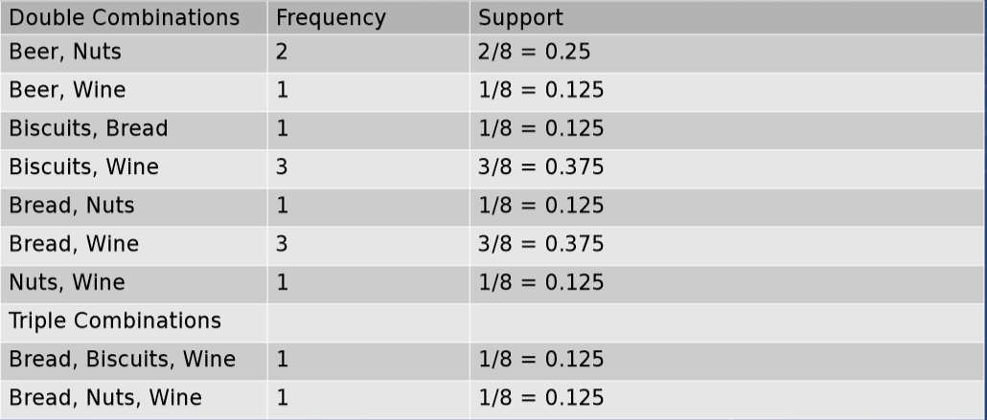

Generate a set of rules and calculate improvement

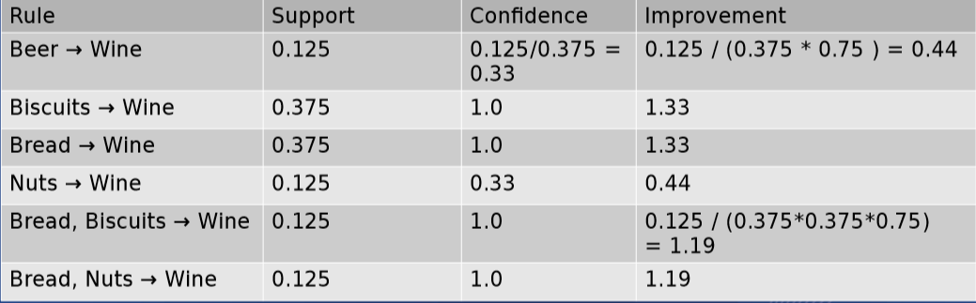

Where did the confidence come from ?

Confidence comes from the whole rules support divided by the preconditions support

What to do once you have found the improvement

Set a limit of less than 1 ?

Gets rid of combinations less than random chance

Monitor how improvement changes

If you have a large number (if not infinite set of rules) focus on the interesting ones

Have to times improvement by 100 to get correct number

# Knowledge based systems

Domain reasoning (medical, shopping, aeronautical)

Deployment

## Production Rules

If condition, then action

## Fallacies of ambiguity

If there are multiple meanings of the word of phrase

Like at rolls with the acronym sheet

## Argumentation ad hominem

Arguments directed against the person not because of what they said

## Fallacy of arguing from authority

Its true because the president said it

## Fallacies that appeal to sentiments

It is true because everyone believes it

it is true because the contrary is unpalatable

## Argumentum ad ignorantiam

It is true because the is not evidence to the contrary (like the convo with Jack)

## Begs the Question

Argument assumed to be true without evidence, other than the statement itself

I’m important because I’m first

## Fallacy of Composition

Whole is true because part is true

## fallacy of division

What is true of the whole is true of the parts

## Fallacy of ignoratio elenchi

Irrelevant convulsion

Missing the point

## Fallacy of non sequitur

Conclusion doesn’t follow the premise A > B Hence C

## Statistical Fallacies

Misrepresentation of statistical information

## Expert systems

Uses domain knowledge with human reasoning about a problem domain or tasks

Shallow knowledge = can me mined/generated

Deep knowledge = experience of decades of work

SIEM

Rules are not gaurentted to catch anything

New rules can drastically chanage the outcome

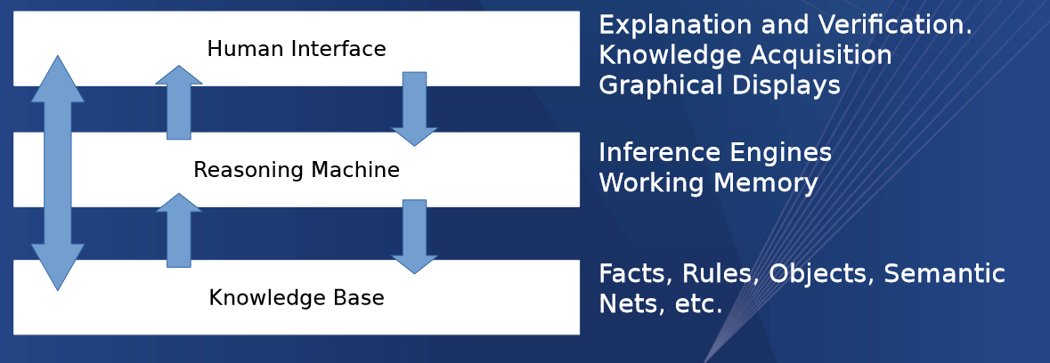

SIEM Requires knowledge of the threat/Threat intelligence in order to change the rule to display or catch threats/threat actors

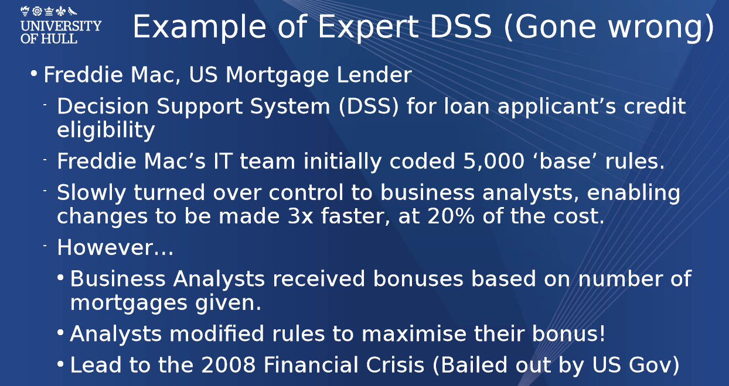

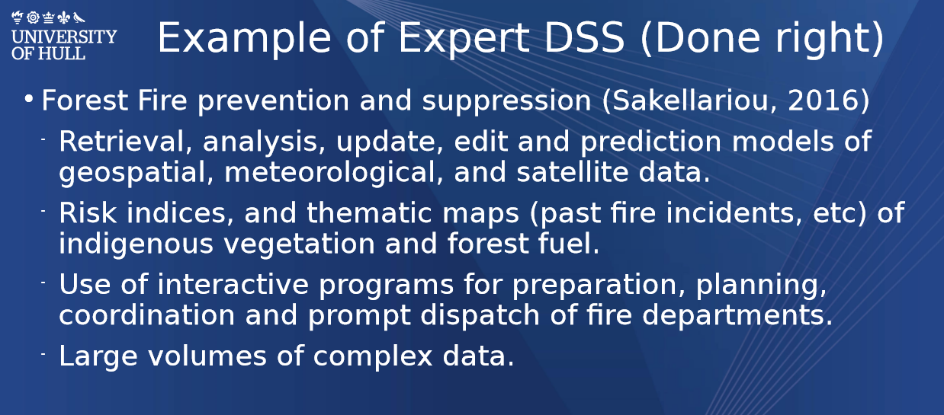

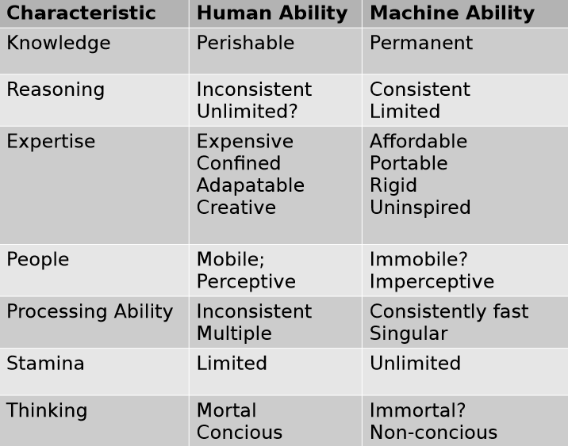

# Closed and Open Worlds

## Closed World Assumption

Presumes that any statement that is true is also known to be true

Alternatively, what is not known is false

This assumes perfect knowledge

## Open World Assumption

Statement may be true irrespective of whether its known

Statements not covered by existing knowledge may be considered unknown

If there’s no statement a deductive reasoner cannot infer the statement is false

## Examples

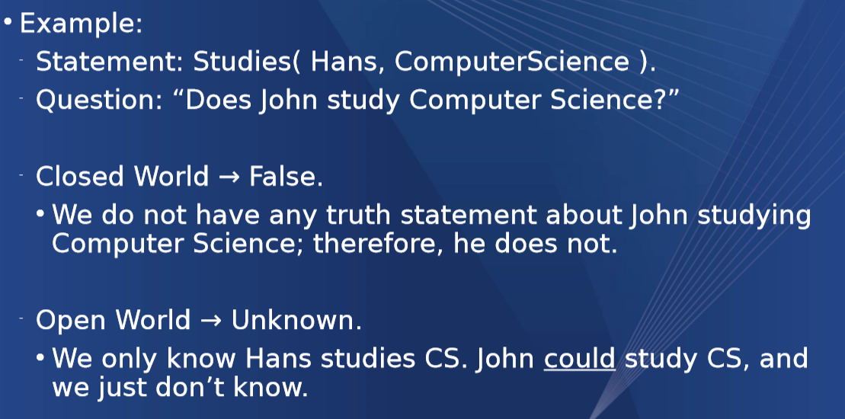

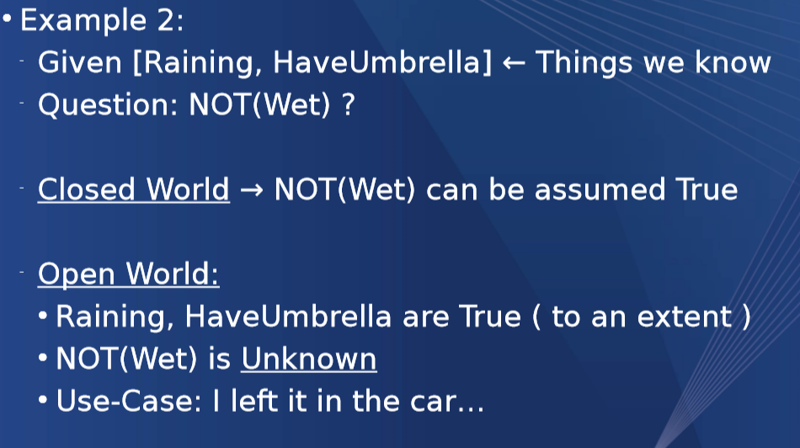

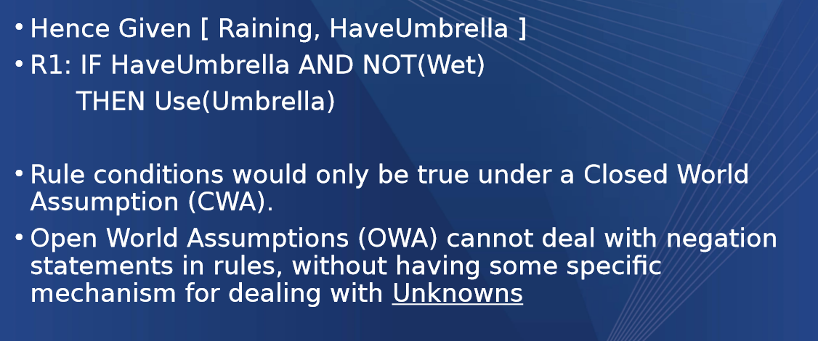

# Conflict sets

Sets of true statements that are applicable to a set of data that conflict

Eg:

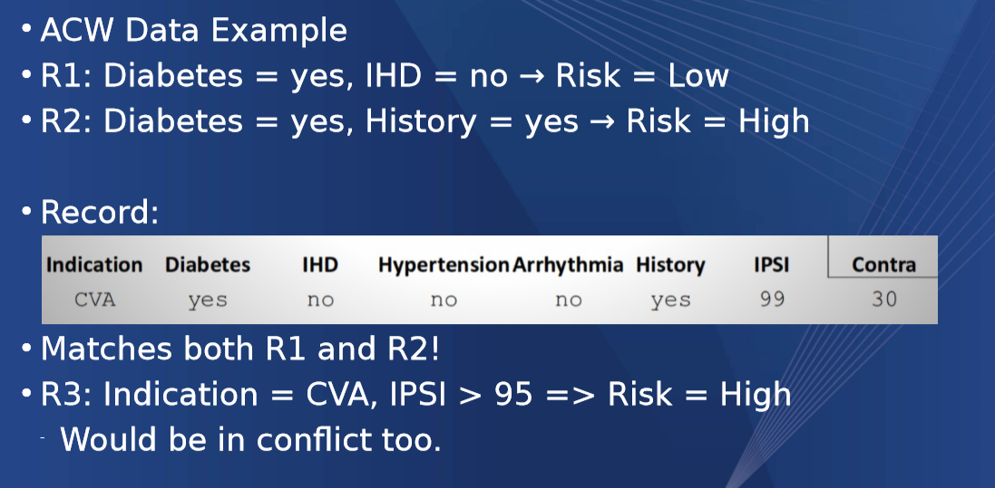

## Resolving Conflicts

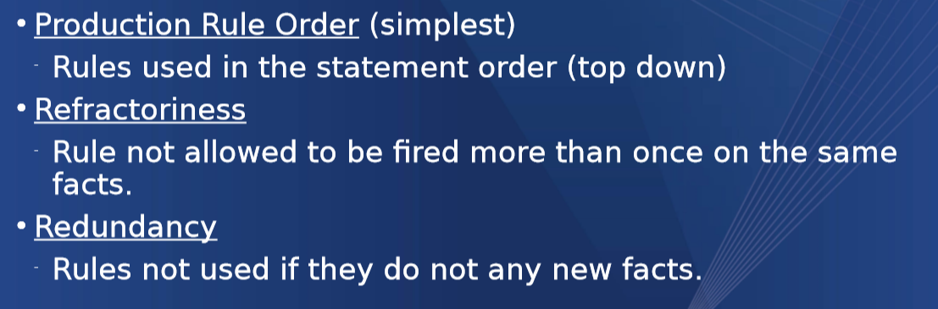

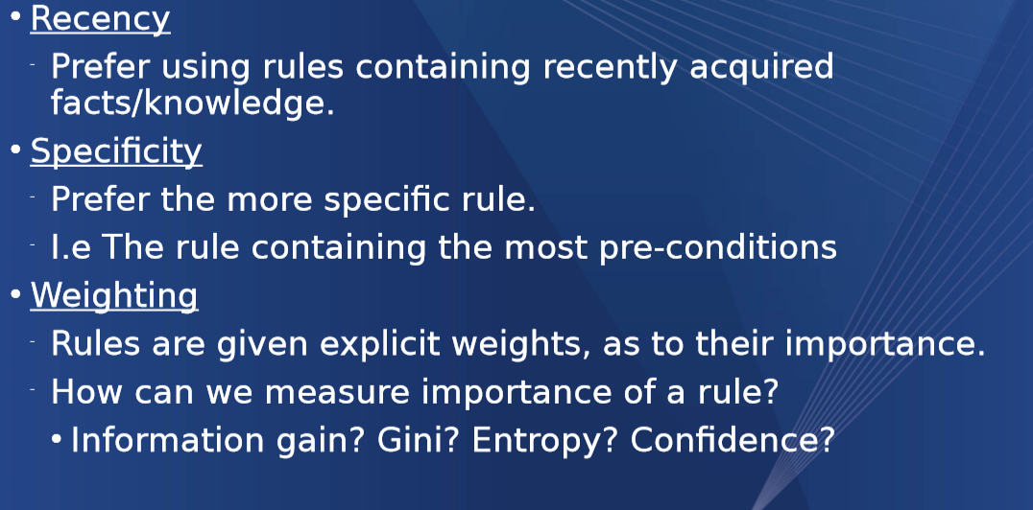

## Determining if rules are adequate

Do my rules intersect?

You can use a decision table to find if they conflict but this inst pheaseable for large systems

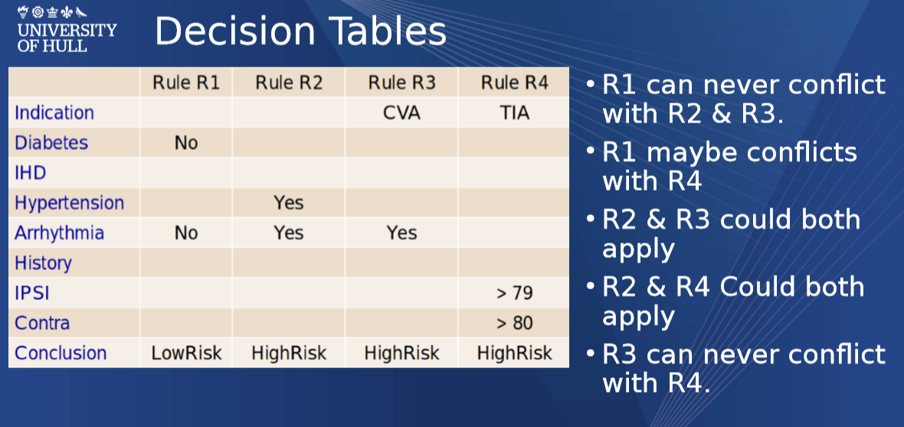

## Alternate Worlds

A decision tree of rules

Conflicts are carried forward and presented as alternative rules

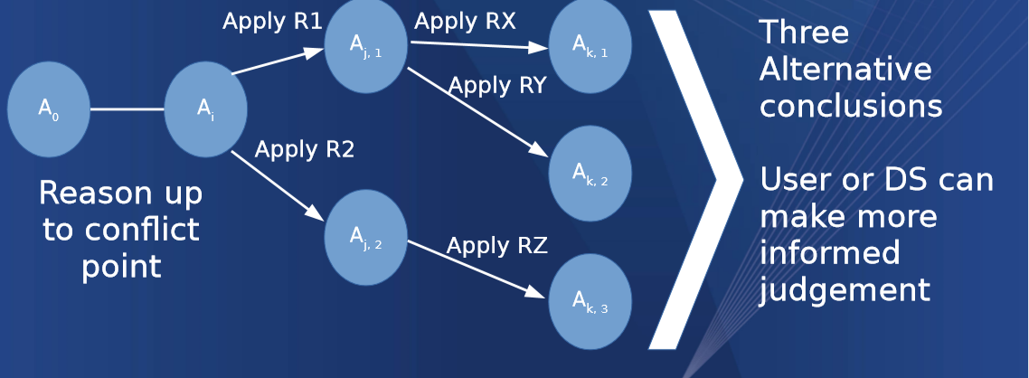

## Forward Chaining

A Method of finding a goal (No Risk, Risk) from a knowledge base and set of rules

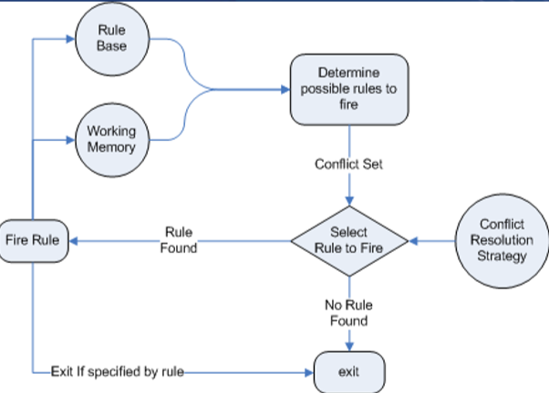

## Backwards chaining

Backwards is goal driven it recursively breaks down the main goal into sub goals then implies the rules based on the breakdown

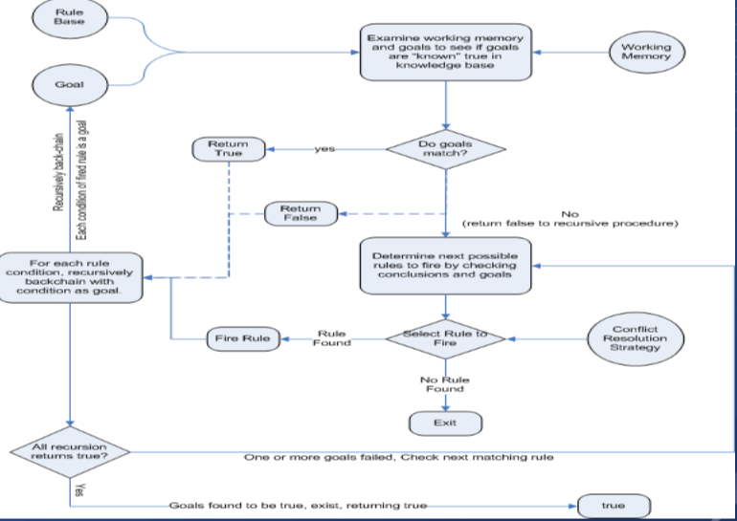

## Use forward or Backward

Multiple goals?

Use forward as more than 1 goal can satisfy the need, backwards would have to consider all goals which is computationally difficult

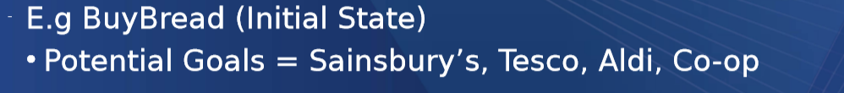

If we need to justify ourselves?

Prefer the direction which shows the way the user thinks

If new facts or information arrives?

Forwards as it can deal with them 1 by 1 as for backwards which may have to start again, if not backwards as its more efficient

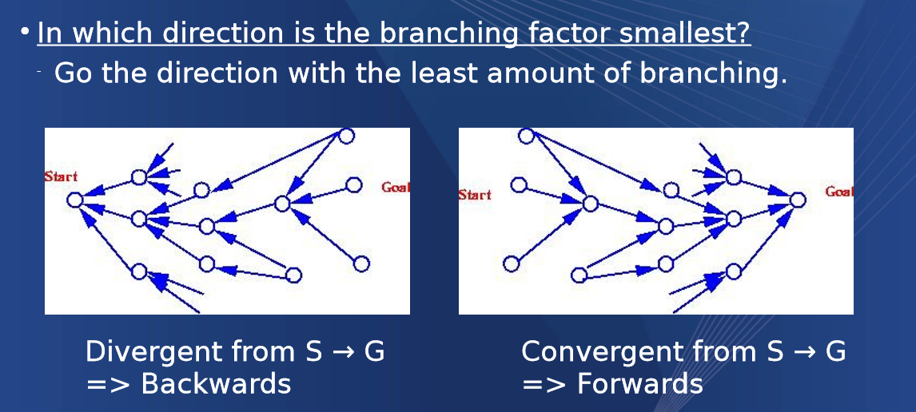

# Neural Networks

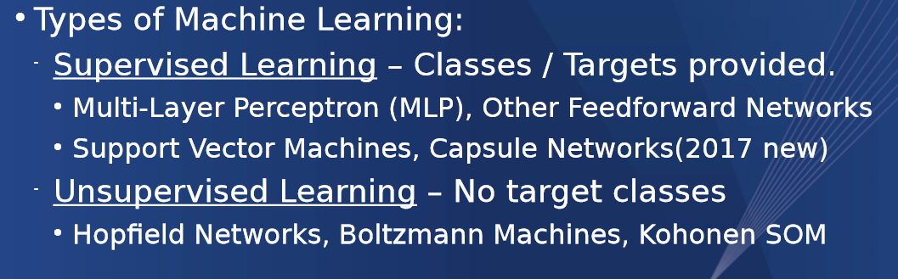

## McCulloch Pitts Neuron

Binary 1 or 0, connection is either fired or not

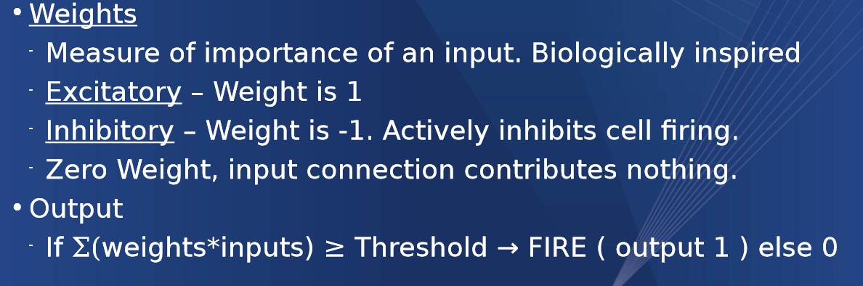

Used to simulate simple logic gates

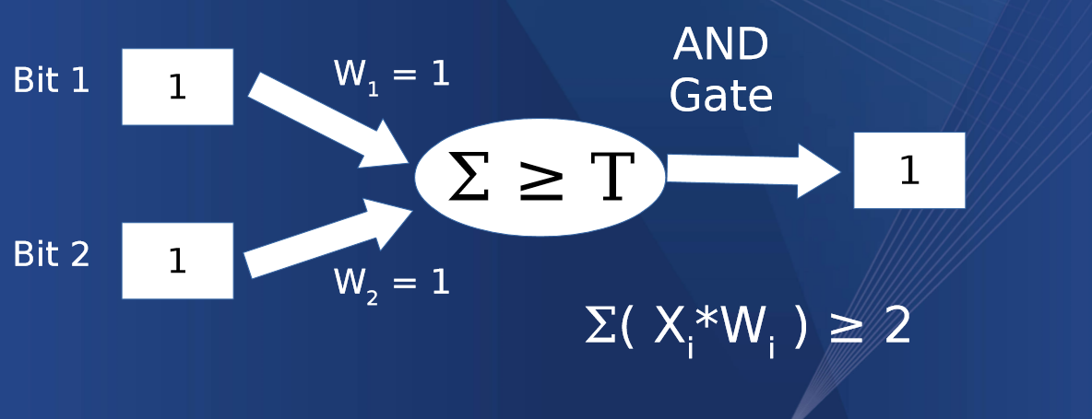

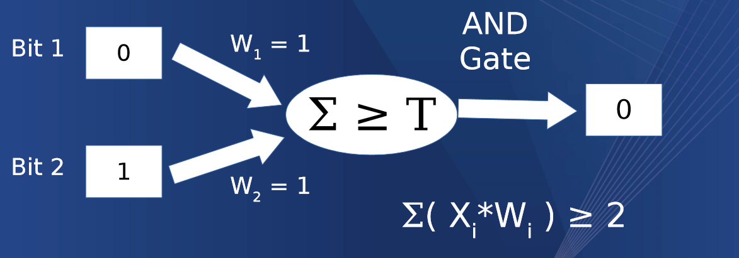

## Rosenblatt Perceptron

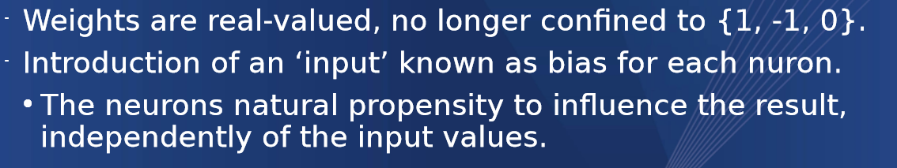

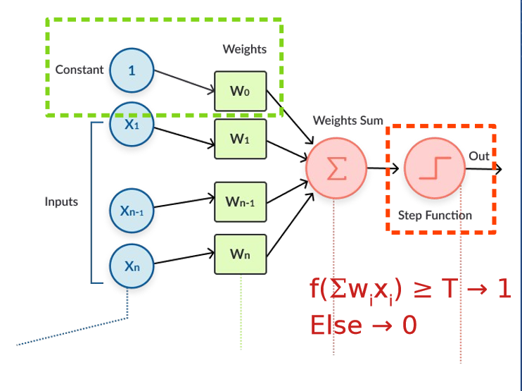

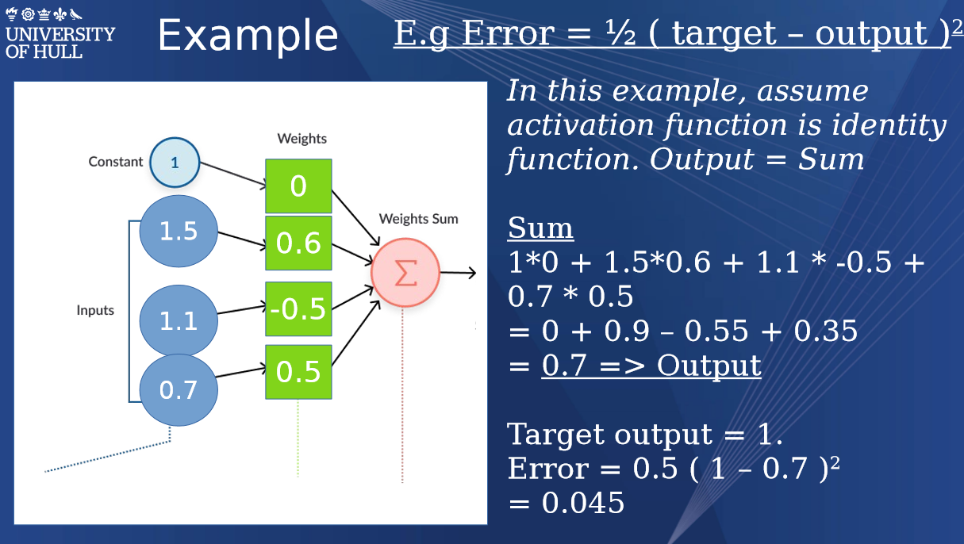

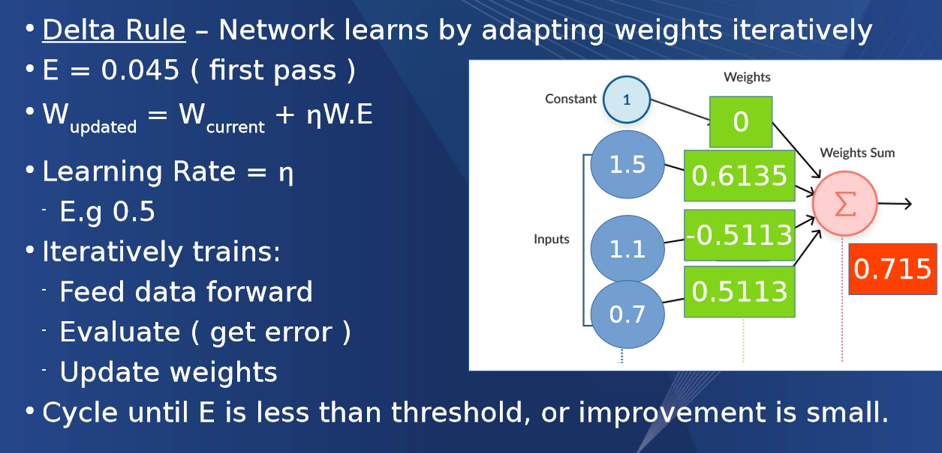

# Multi-Layer Perceptron’s

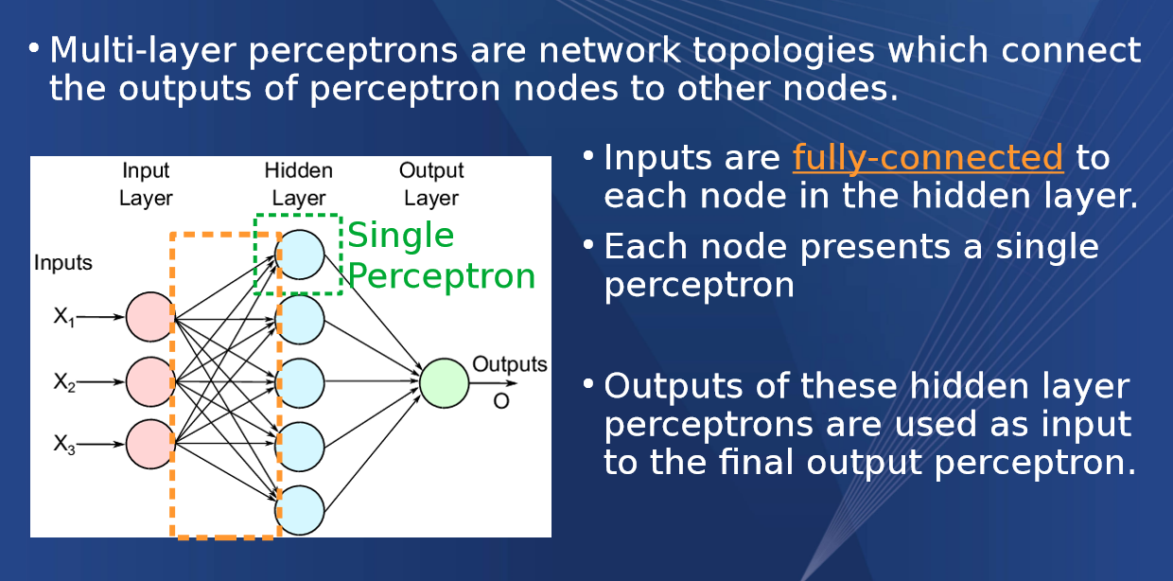

# Best to watch the lecture if this stuff is required however I do get the main premise of a NN